Reversing Miscellaneous Entries

**Issue:**

A student had issues posting her online application check payment. PayPal indicates she made two payments, but one was voided which resulted in a $25 charge which is correct. TGACREV reflects total online check payments for that date at $50 rather than the correct payment amount of $25. Her student account in Banner after the applications were pulled in has one $25 check payments which means the other $25 payment is hung in miscellaneous revenue.

**Correction:**

Make sure you have a clean cashier session. This can affect your overall cashier session totals, so making sure to do this in a clean session is important.

In Banner go to the TSAMISC form, leave the Receipt Number, Document, and ID fields blank and CTRL+PGDN.

Since the entries in the MISC tables are not tied directly to a student, you do not need to enter data here because the adjustment you want to make is to the data in the MISC table that is not tied to a student.

Then enter the data below to **reverse** your entry. This will credit the existing 3APP in the table and debit the existing APPL in the table essentially reversing the entries. This example uses a 3APP but you would change that detail code to whatever you need it to be – i.e. 2APP etc. 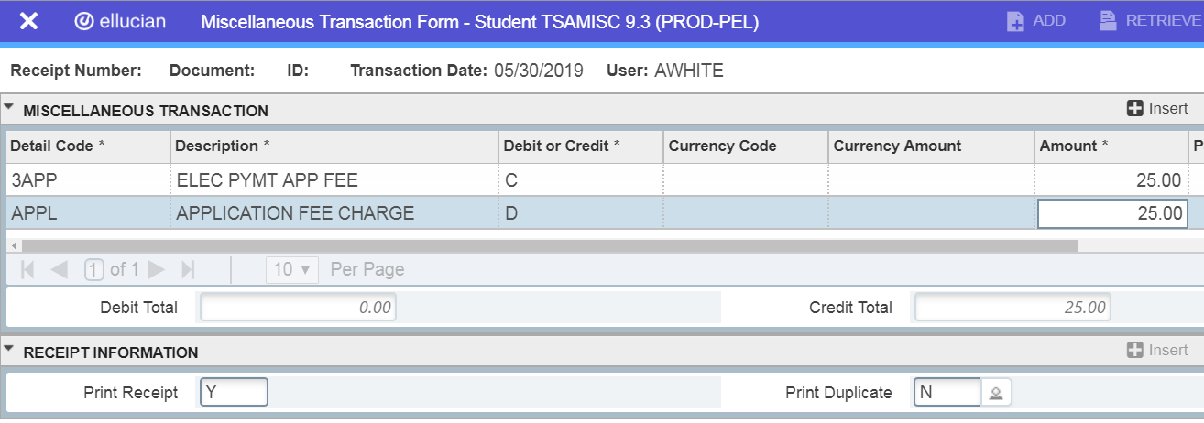

Hit F10 to save the entry and it will place a receipt number in the receipt field.

This will create a cashier session for the Banner ID that creates the entries on TSAMISC. This will be your reconciling cashier session.

If your numbers on your TGRRCON are negative numbers, then you will need to do the opposite of what you would do to reverse the entry.

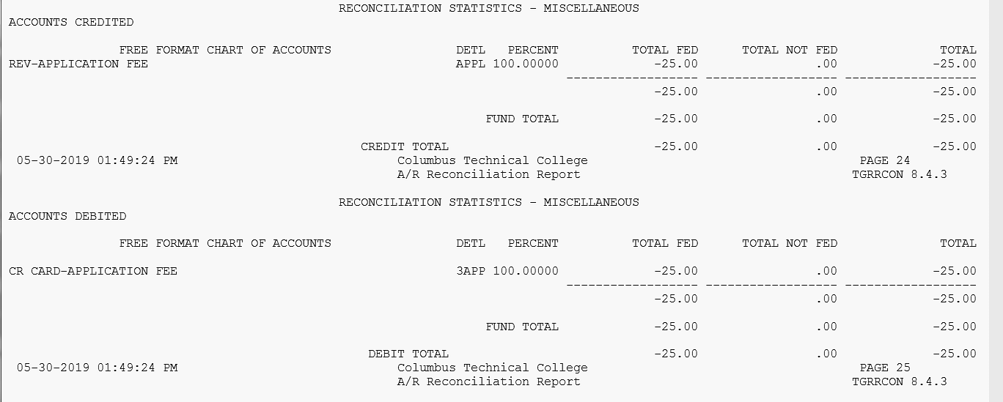

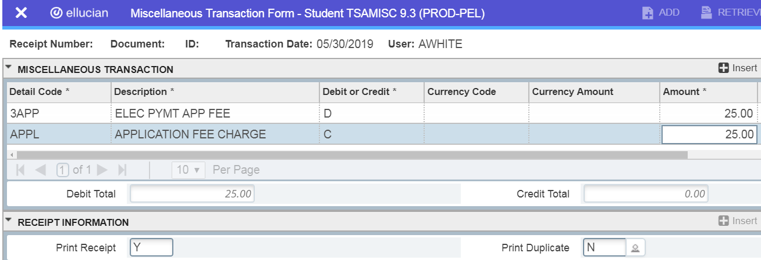

Hit F10 to save the entry and it will place a receipt number in the receipt field.

This will create a cashier session for the Banner ID that creates the entries on TSAMISC. This will be your reconciling cashier session.