Documentation for Removing Application from Student Portal (During Business Office Balancing)

From last year, TCSG has already created the portal without application. You would need to edit the message and publish the site when you are ready. Once publish the portal, student will not be able to apply.

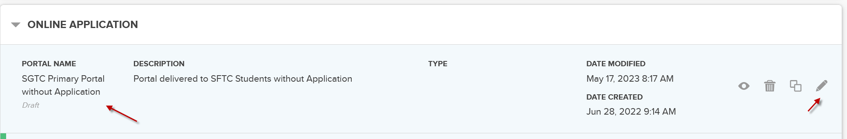

Edit the message and click on Publish.

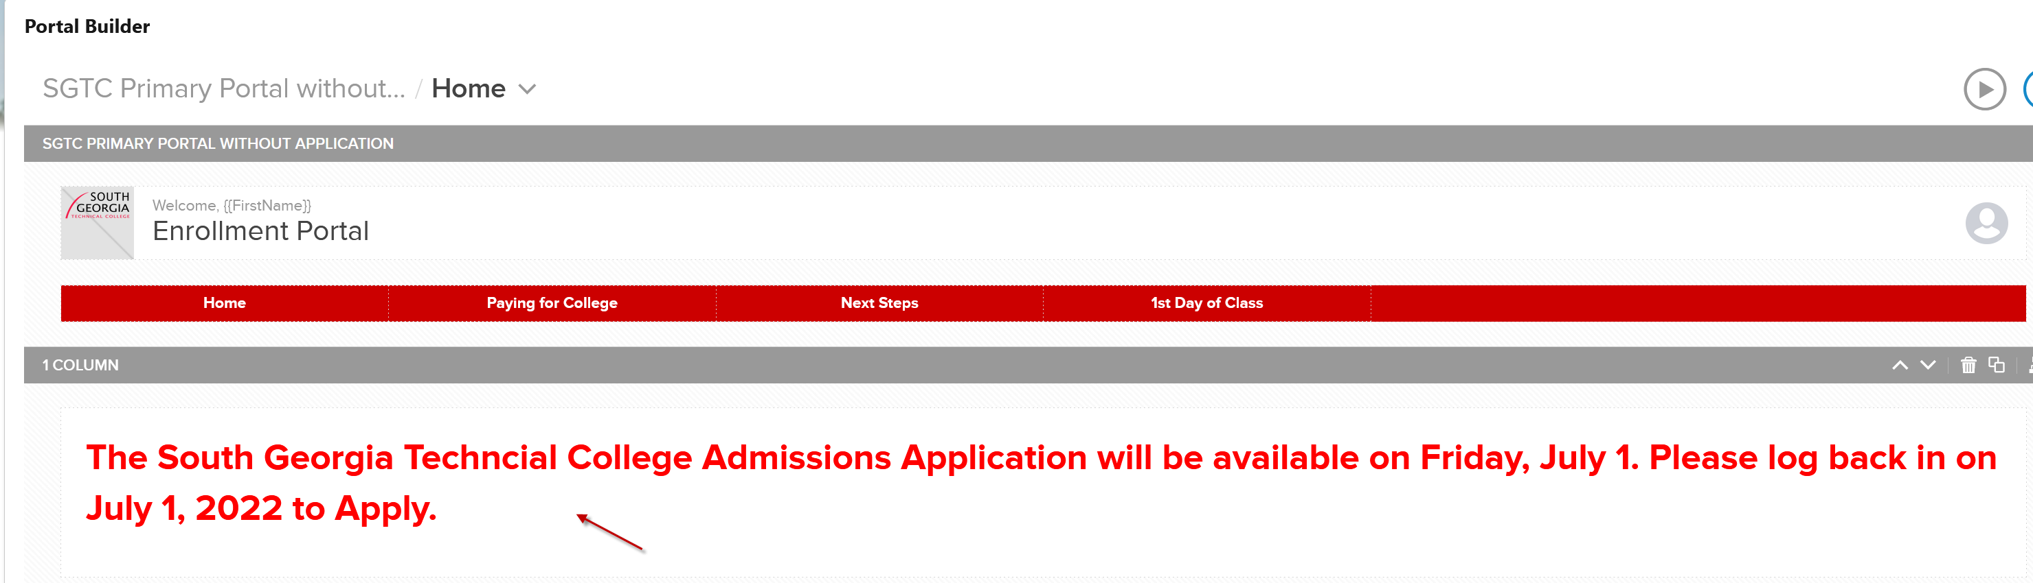
Note: Change July 1, 2022 to current year. 2024

OR If the college does not have the portal setup for the

- Using this documentation, you will create a version of your current Student Portal that will remove the “Apply Now” button and “Application Progress” widget from your portal.

- The “Portal without Application” will include a descriptive message informing students that the application will be down until [insert date].
  - *NOTE* This is intended for colleges who DO NOT want to offer the application at a $0 fee

Step 1
Navigate to the “Portal Builder”. Using your most up-to-date portal (primary portal for students) create a clone by selecting the option below.
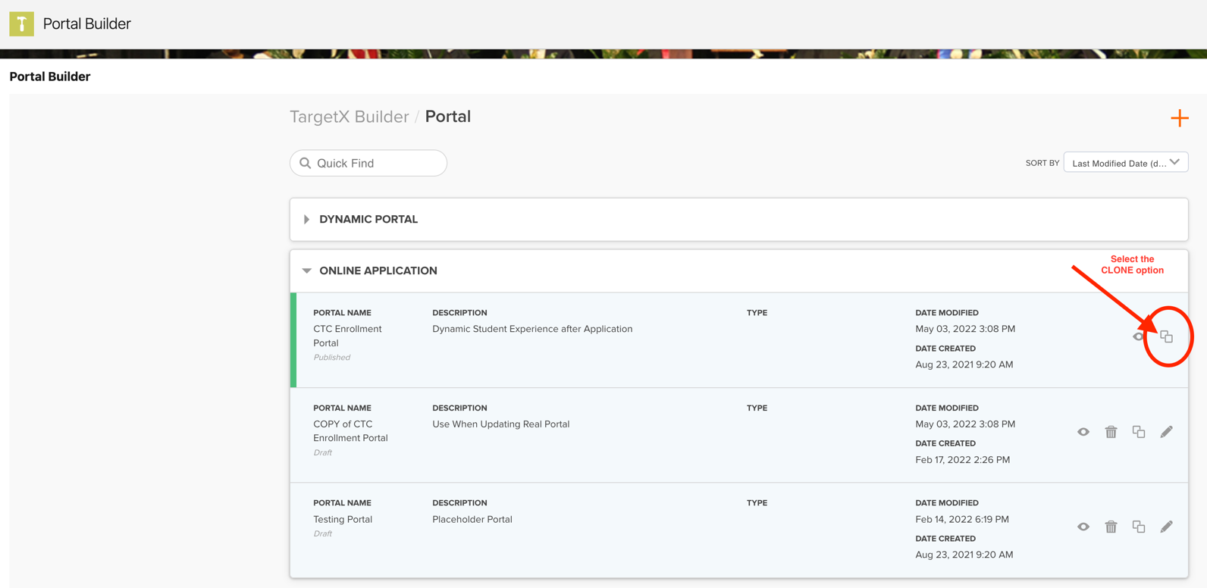

Step 2
You will be served the “Create Portal” screen. Follow the steps below for the description to ensure no confusion will occur when publishing your student portals. Then continue by selecting “Create”
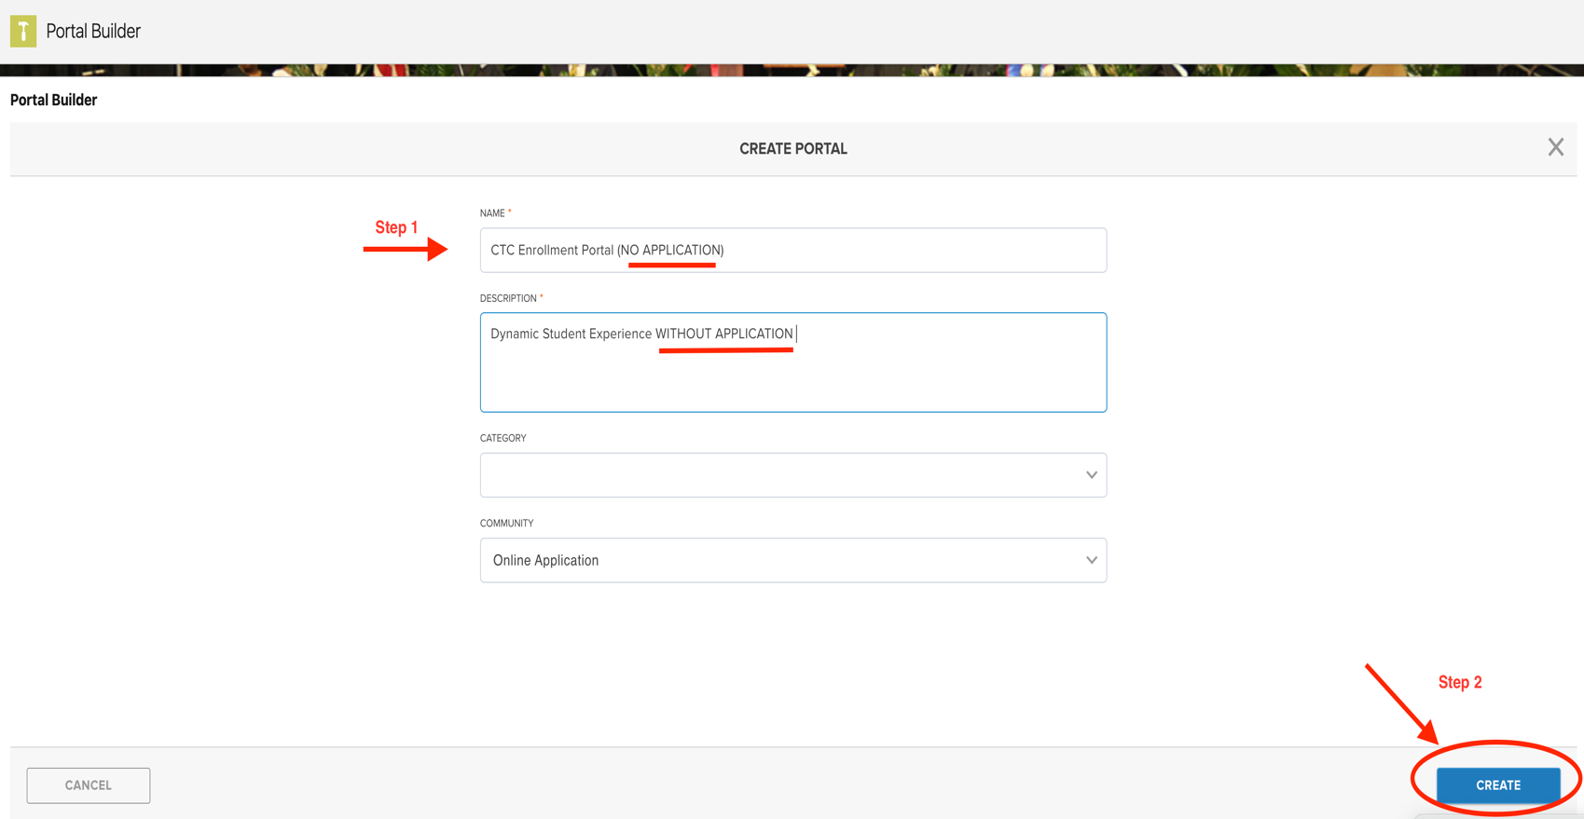

Step 3
Once in the portal, click on the “App/Checklist” widget to select the section you wish to remove. Select the “Remove” button
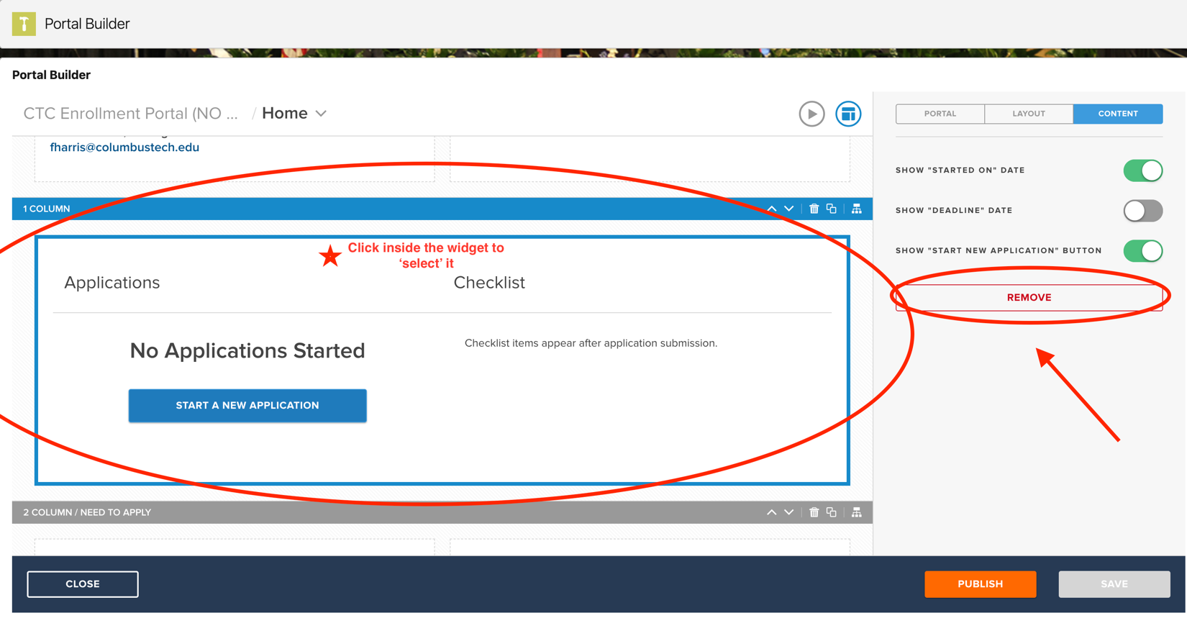

Step 4
When served the “Warning”, select “I Understand” and then proceed to “Delete”
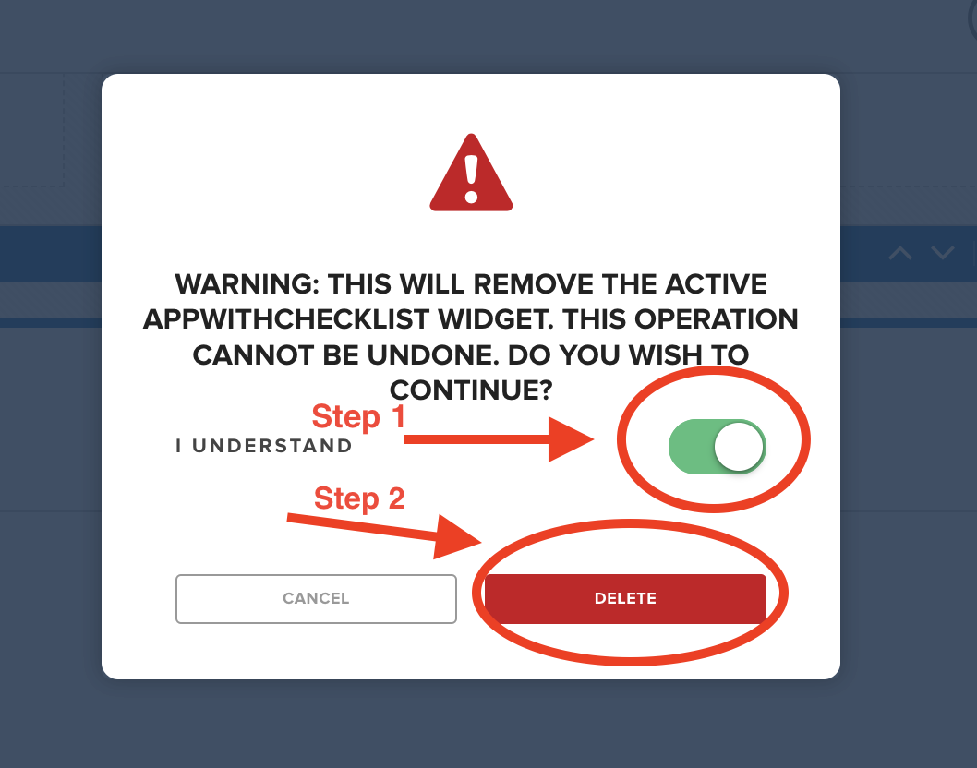

Step 5
Select the blank widget space, and insert the “Text” widget

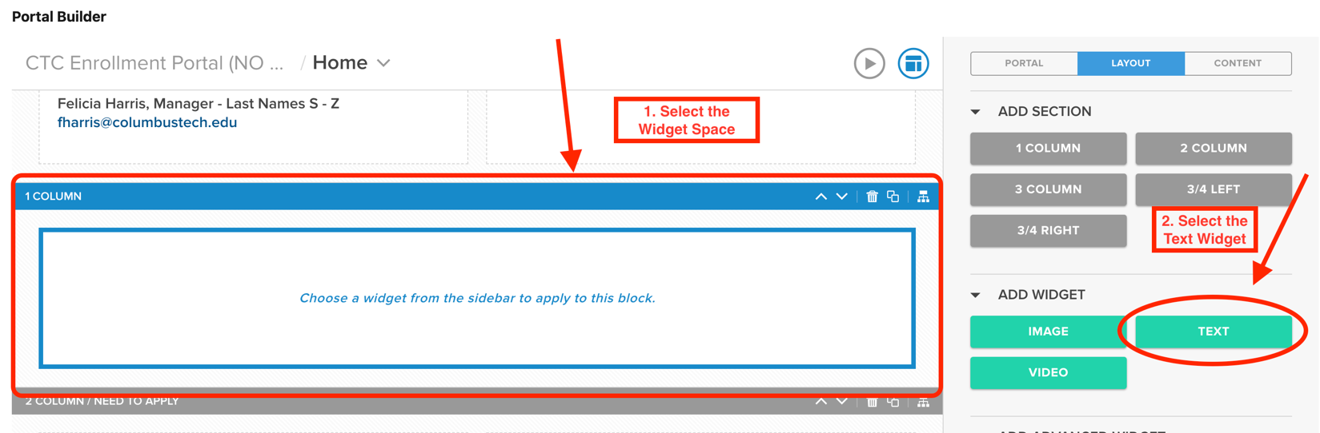
Step 6

Insert Application Down language (text below is only an example). Ensure that the “Text Widget” is moved to the top of your portal page

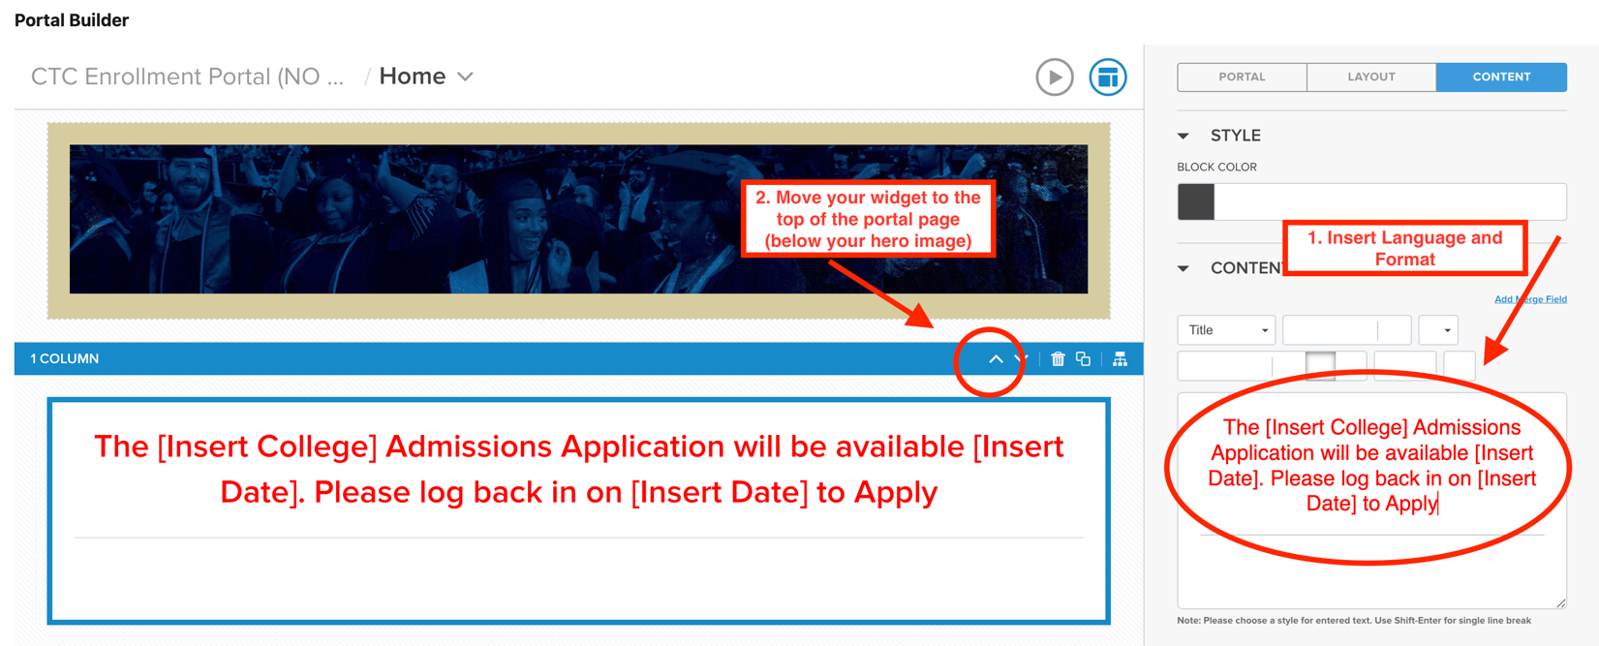

Step 7

Repeat steps 3-6 on all tabs in the Student Portal where your Application Widget is placed. Once all tabs have the widget replaced with Application Down text, SAVE

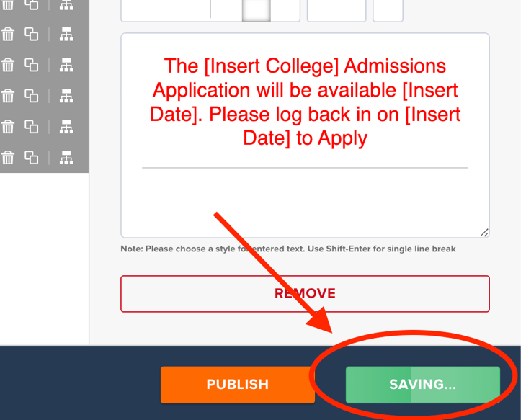

Step 8

When your college determines what day/time the application will be taken down, publish your copy of the portal WITHOUT APPLICATION.

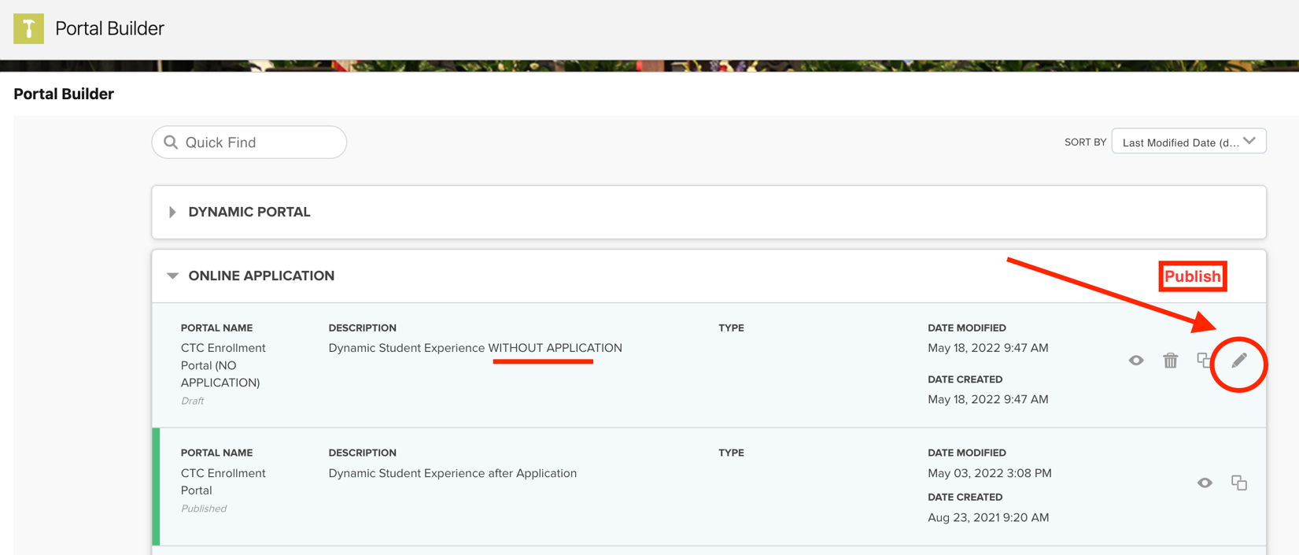

Step 9
At the conclusion of the “app unavailable” period, publish your original student portal containing the “App/Checklist”
