TGRUNAP – Mass Unapply.

The following process is setup to run TGRUNAP (Mass – Unapply) with a population selection for a certain term. This pop-sel finds registered students for a certain term. (These are the students you want to unapply.) TGRUNAP will unapply everything for those students in that pop-sel for the term entered.

Use caution when running TGRUNAP, if ran incorrectly it can cause problems. Ensure you are using the correct parameters and verify that TSAMUNA is empty before running TGRUNAP. (Angela recommends running TGRUNAP with a population selection.

Follow the steps below.

- Finding Registered Students.

Setup the following population selection. Make sure you save it and click on the X in the upper right hand corner so that the pop-sel compiles.
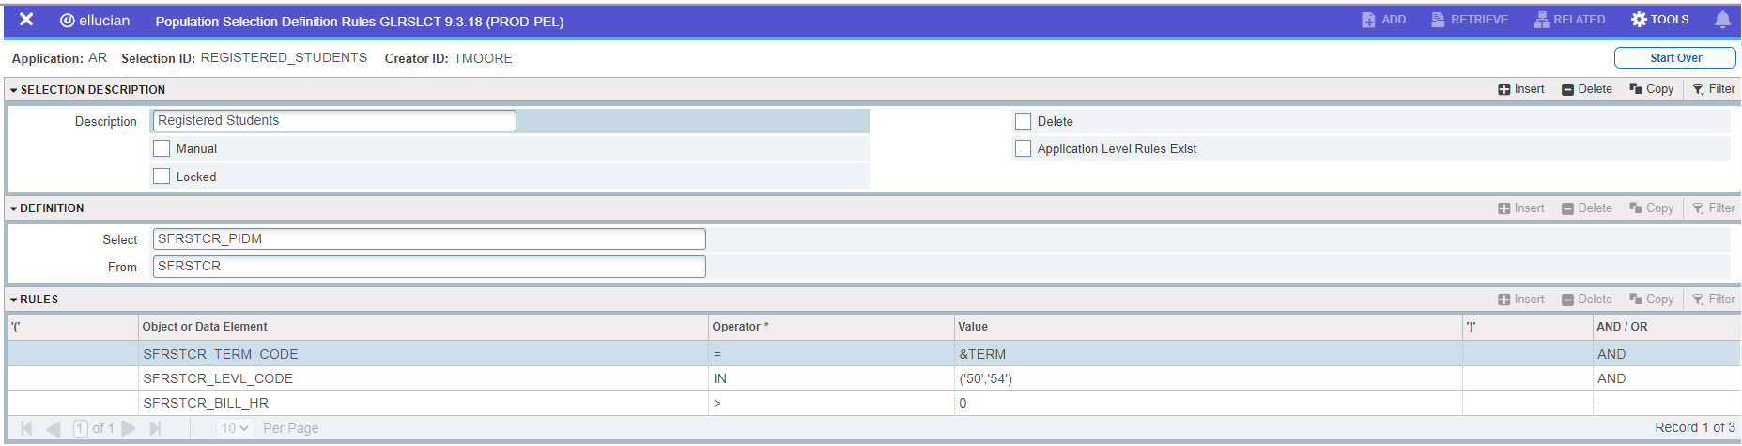

Run GLBDATA with the REGISTERED_STUDENTS population selection
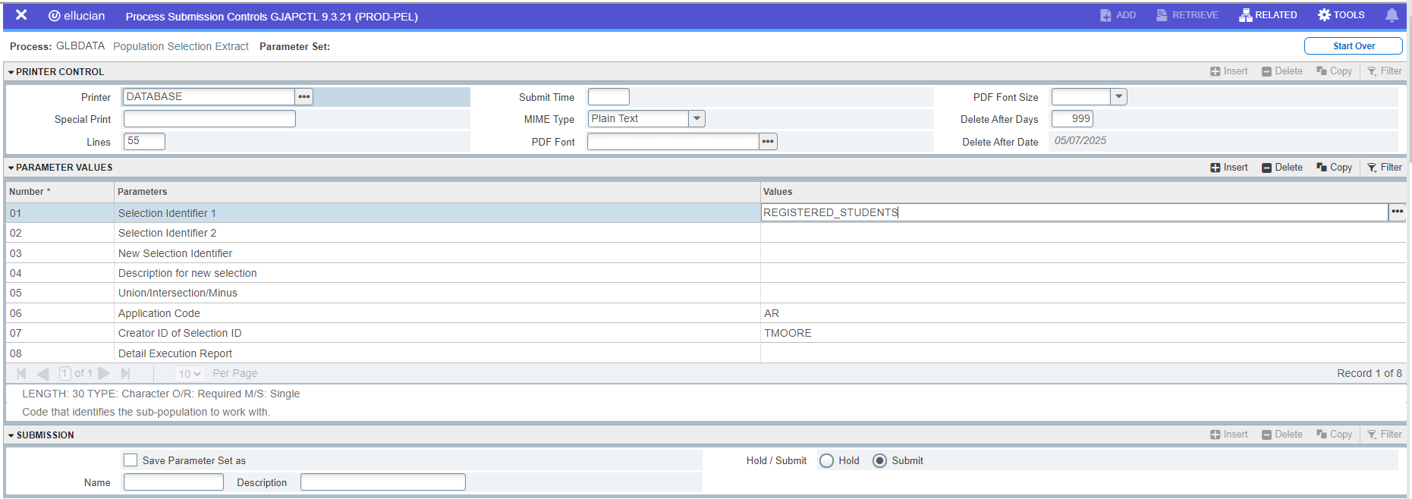

Once you run the pop-sel. Review your .log file to see how many students you should have.
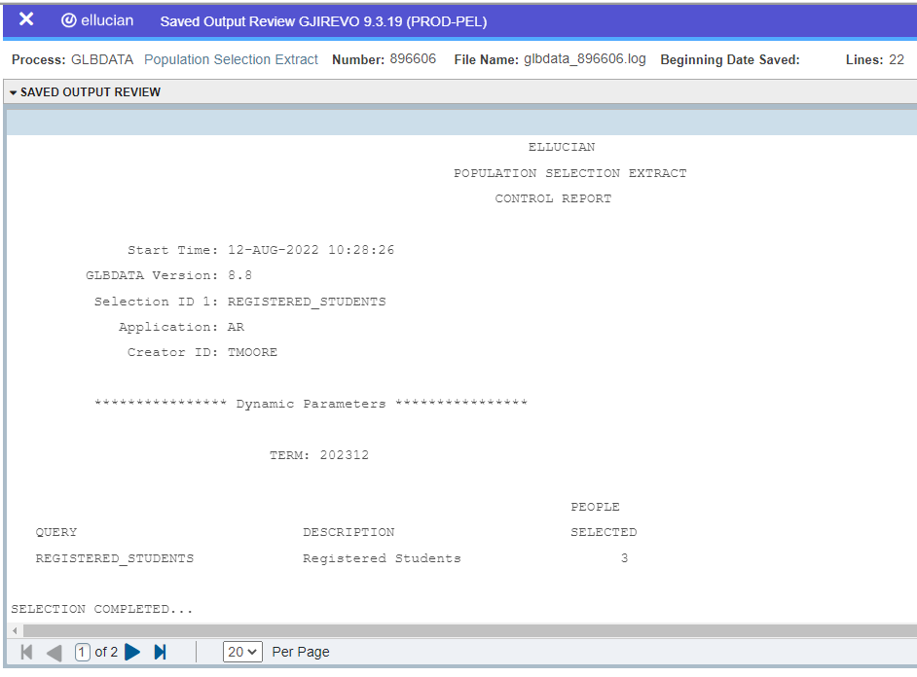

Then go to GLAEXTR to review your list of students. Verify they are the correct students.
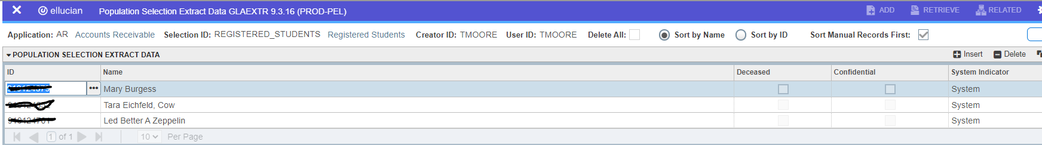

- Go to TSAMUNA and verify the table/form is empty.

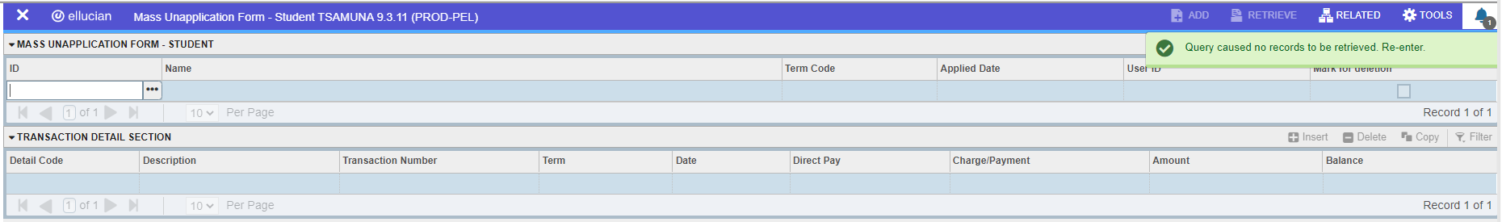

Note: Most of the time this table/form will be empty, but if it has data, you will need to delete all of the records before running TGRUNAP. If you find students, use the Delete button to remove the students.

- Run TGRUNAP – with your population selection and enter the following parameters:

Parameter 01 – B (Both)
Parameter 02 – N
Parameter 03 – REGISTERED_STUDENTS
Parameter 04 – AR
Parameter 05 – Your Creator ID
Parameter 07 – Enter Term
Parameter 09 – N

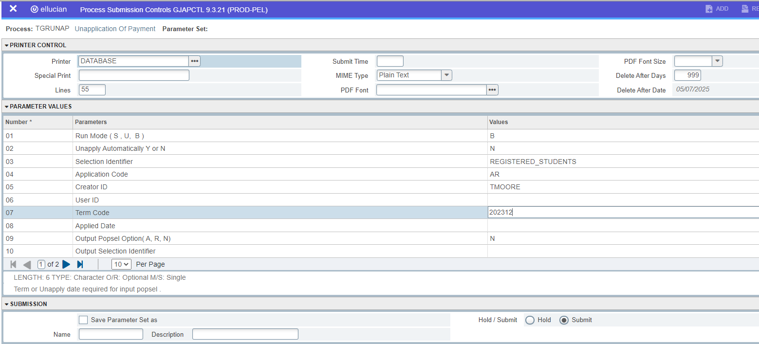

Review your .log and .lis file. Review your data.

