Variable Rule Definition and Pop-Sel used with their Due Diligence Procedure (Savannah)

You will want to make sure you have the Variable Rule Definitions setup.

Go to:

GLRVRBL – Variable Rules Definitions

*STUDENT_MAX_SUBQUERY

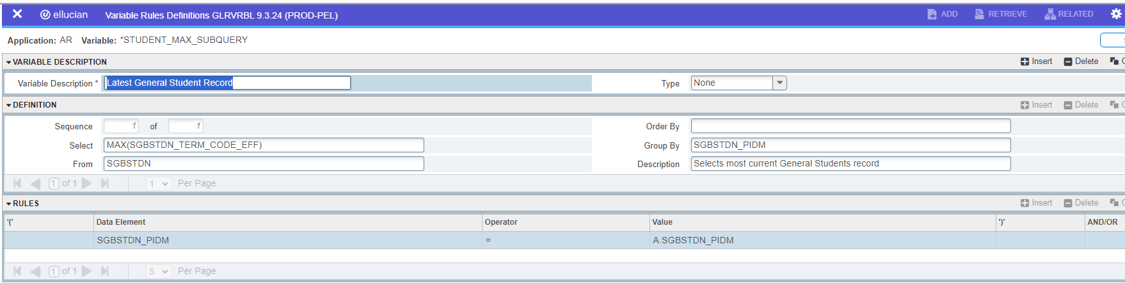

Make sure you have these population selections setup.

Go to:

GLRSLCT – Population Selection Definition

BILLED_STUDENTS1 - Billed students <= term (no High School students)

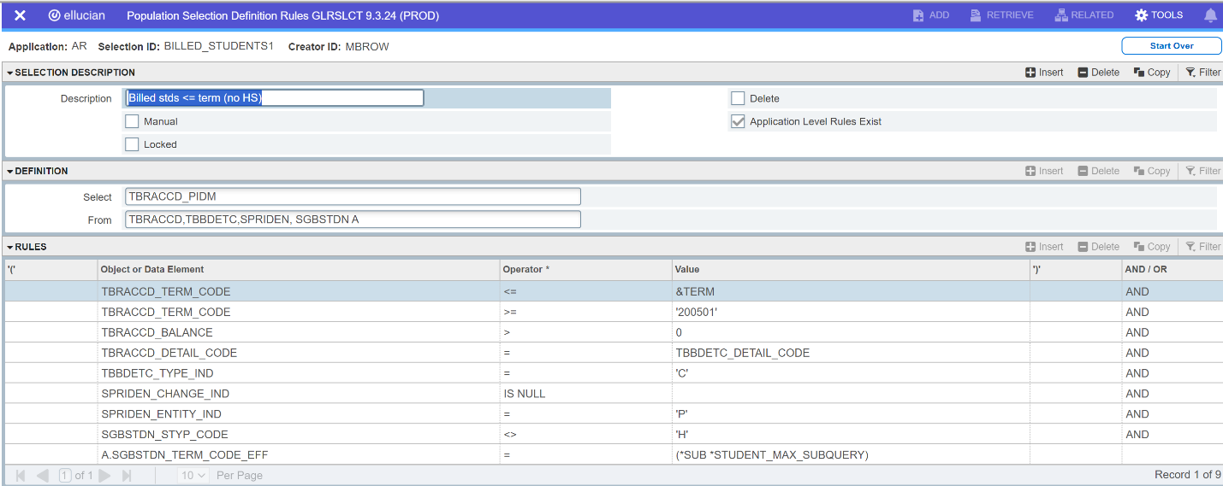

BILLED_STUDENTS2 - Billed students with Bankruptcy and do not include High School Students.

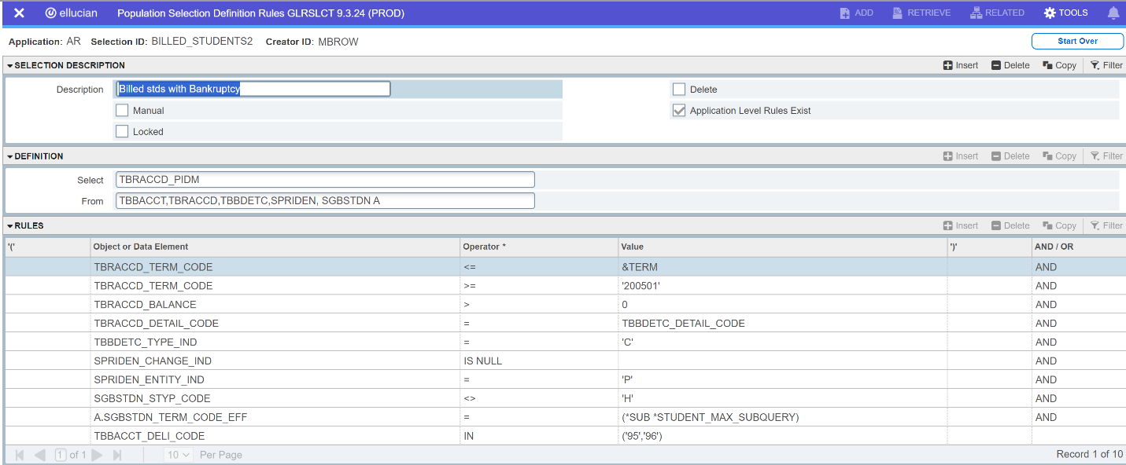

BILLED_STUDENTS3 - Billed Students <= term (includes High School Students) your college may or may not bill high school students. If you do not, you will not use this pop-sel.

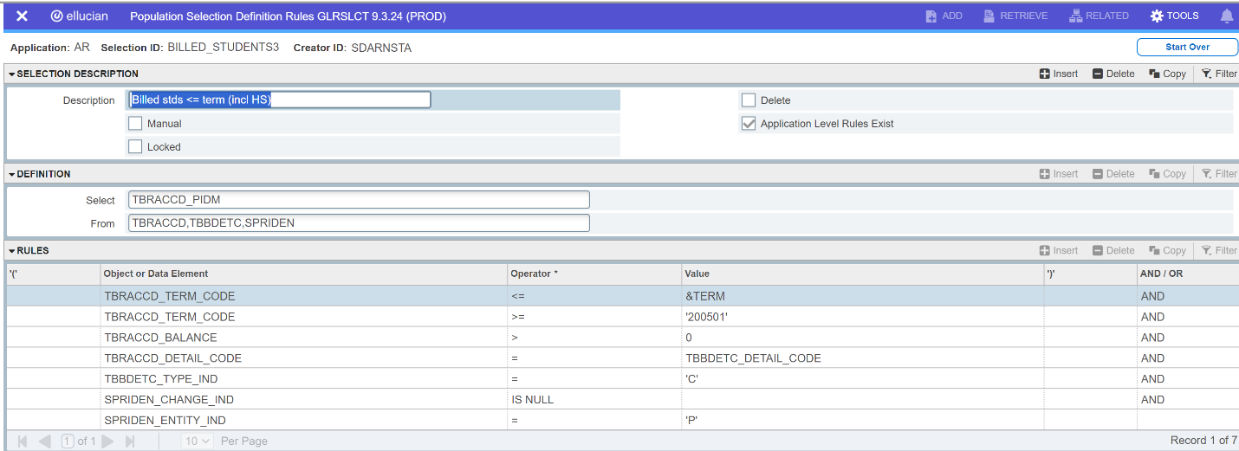

BILLED_STUDENTS4 - Billed students with Bankruptcy

