Due Diligence Letter Procedure (Savannah)

You will want to make sure you have the Variable Rule Definitions setup.

Go to:

GLRVRBL – Variable Rules Definitions

*STUDENT_MAX_SUBQUERY

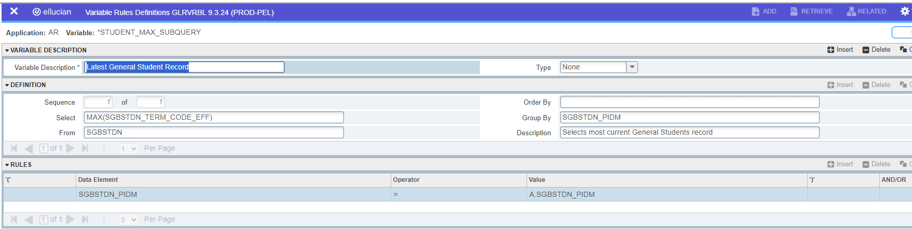

Make sure you have these population selections setup.

Go to:

GLRSLCT – Population Selection Definition

BILLED_STUDENTS1 - Billed students <= term (no High School students)

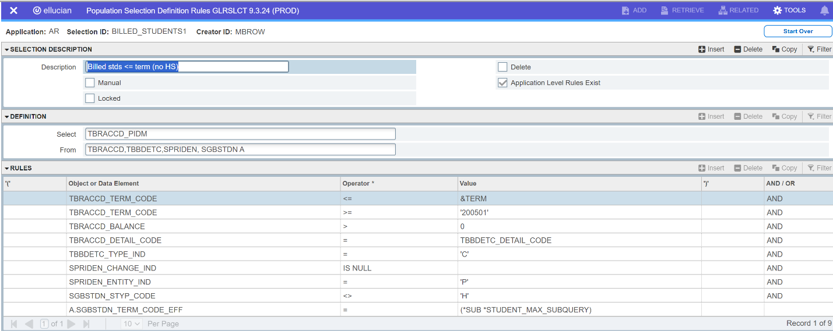

BILLED_STUDENTS2 - Billed students with Bankruptcy and do not include High School Students.

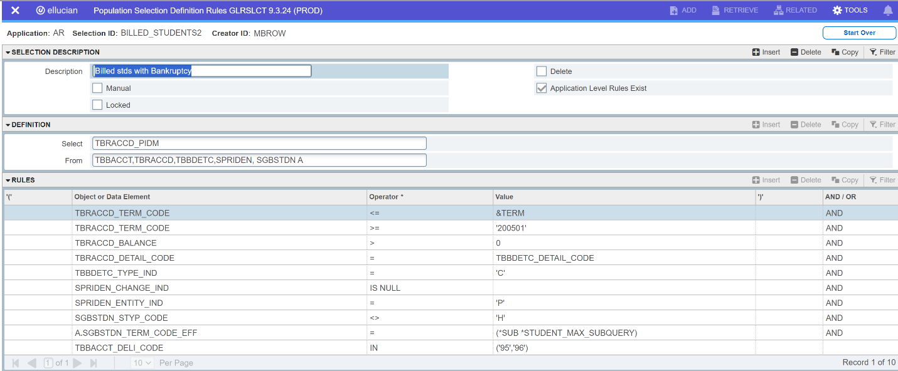

BILLED_STUDENTS3 - Billed Students <= term (includes High School Students) your college may or may not bill high school students. If you do not, you will not use this pop-sel.

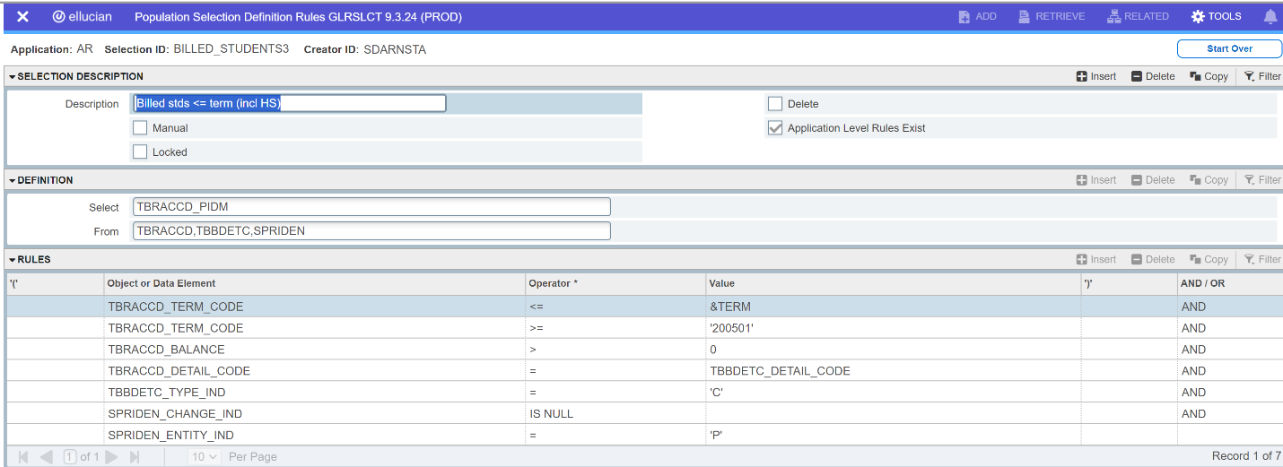

BILLED_STUDENTS4 - Billed students with Bankruptcy

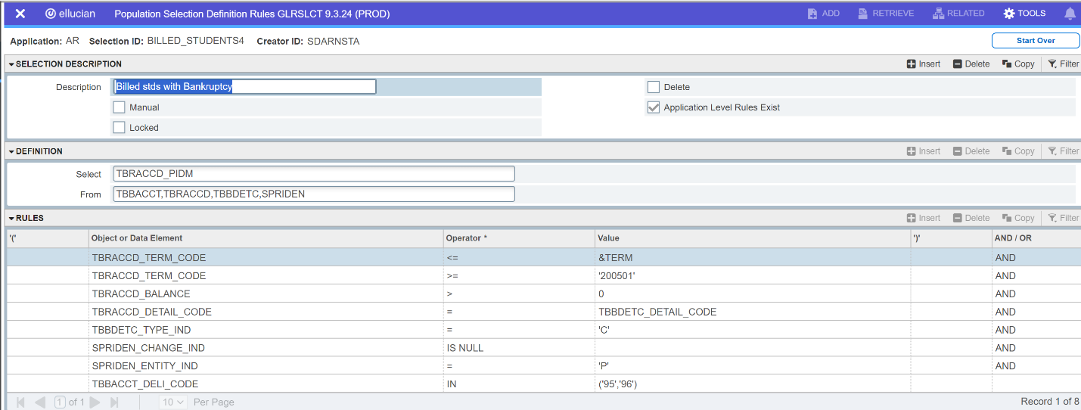

Note:

BILLED_STUDENTS1 and BILLED_STUDENTS2 are used together (no high school student and minus out the bankruptcy students)

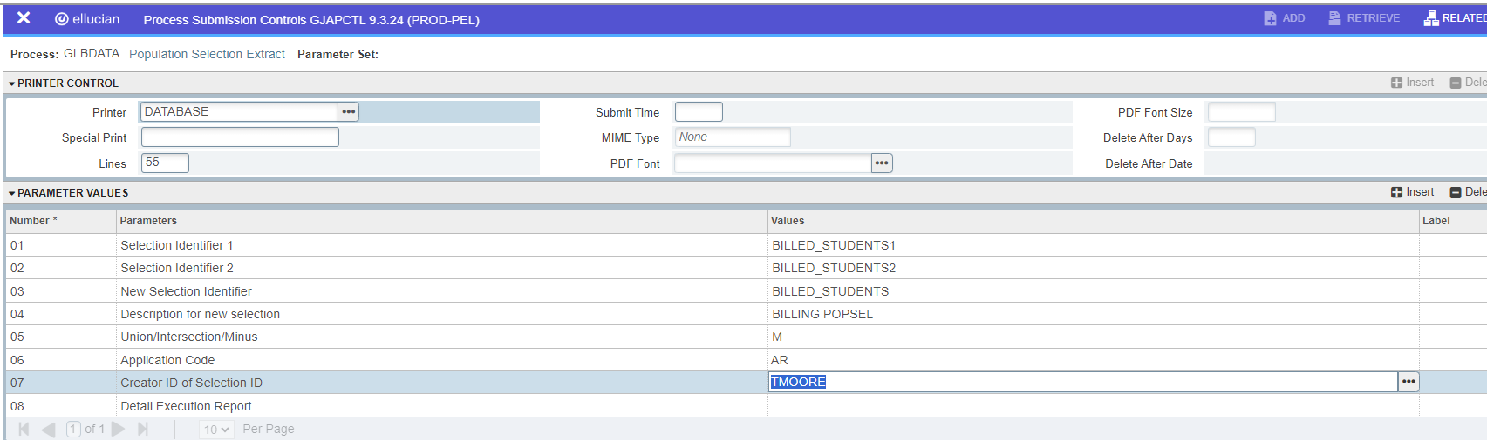

BILLED_STUDENTS3 and BILLED_STUDENTS4 are used together to include High School students and Bankruptcy. If you college doesn’t bill HS or Bankruptcy students, you will not use these two population selections.

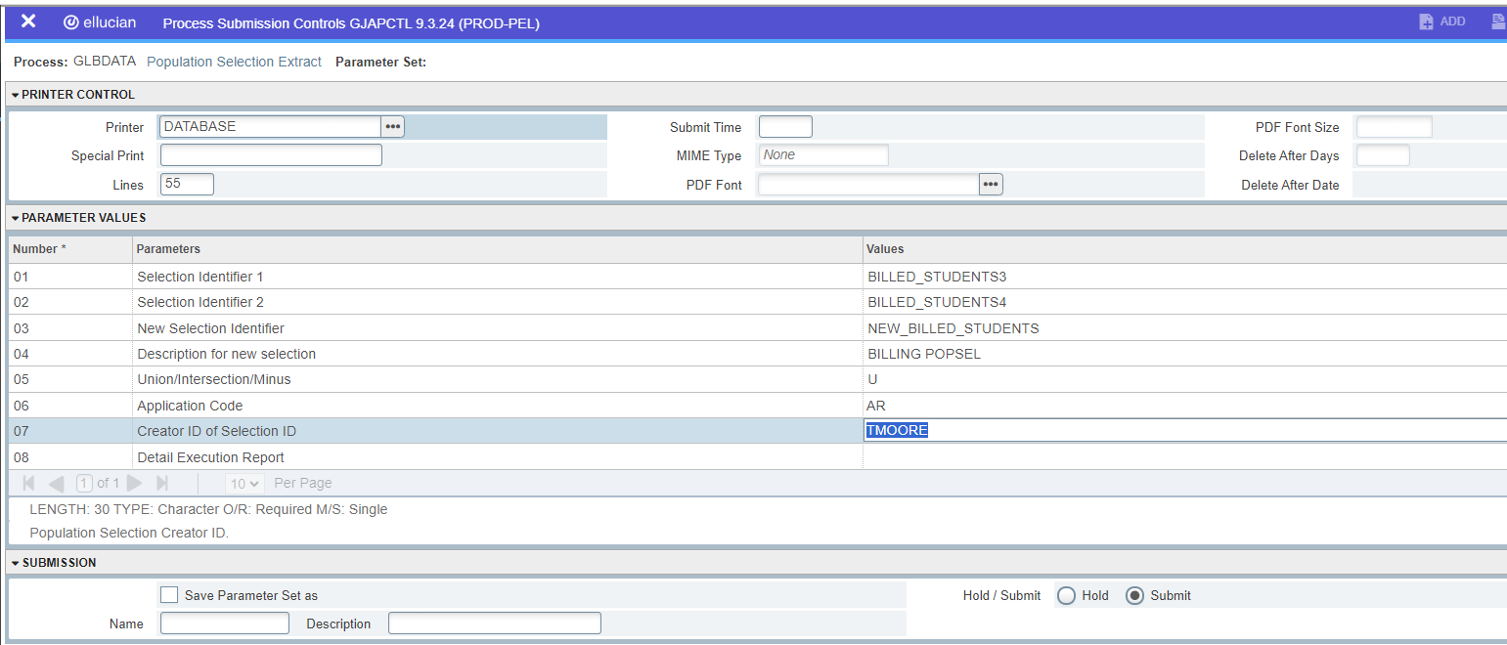

**DUE DILLIGENCE PROCESS**

In Banner go to GLAEXTR and enter the following information.

Application: AR

Selection ID: NEW_BILLED_STUDENTS

Creator ID: Who created the pop-sel BILLED_STUDENTS

User ID: The user running the process

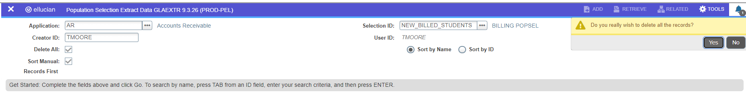

Mark Delete All – this will delete the student list from the previous billing, run before you begin a new due diligence run.

In this example we will use BILLED_STUDENTS1 AND BILLED_STUDENTS2 (This will find the students who need to be billed but **exclude** the High School and Bankruptcy students)

Go to GLBDATA

Enter the following information.

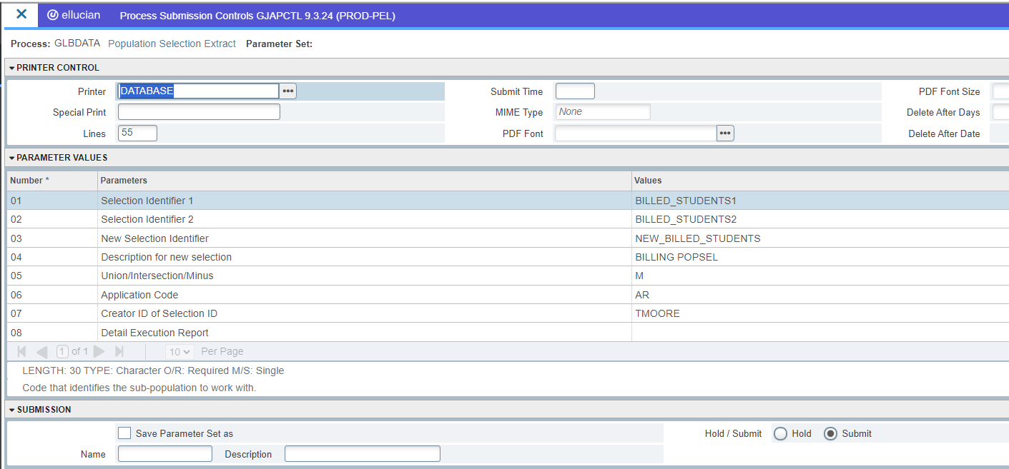

Parameter 05: Use M to Minus out the High School and Bankruptcy students

When you click save – you will prompted to enter a dynamic parameter for the Term.



Click save. Review your .log file.



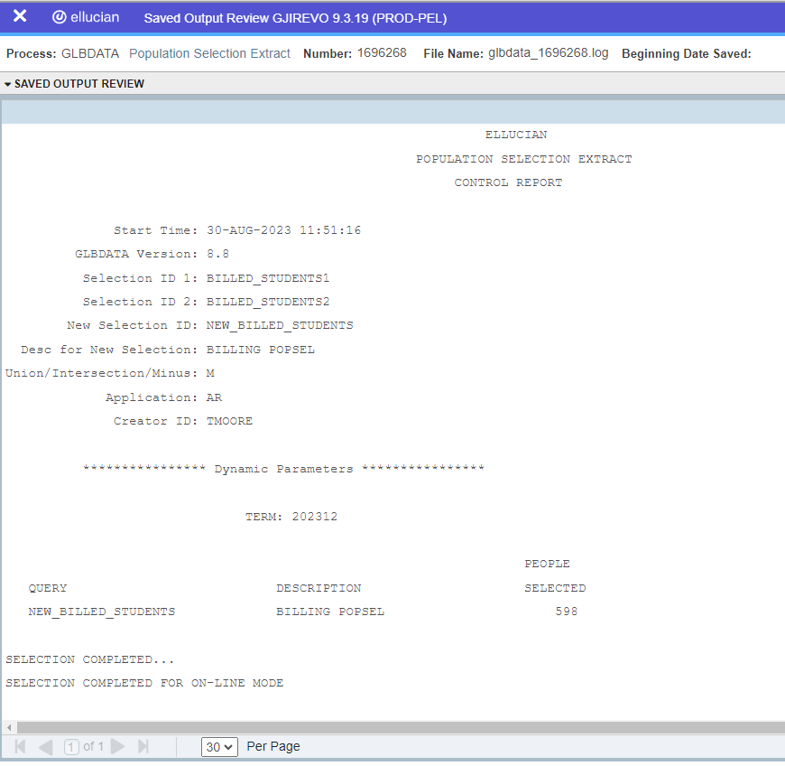

Then go to GLAEXTR to view your students.

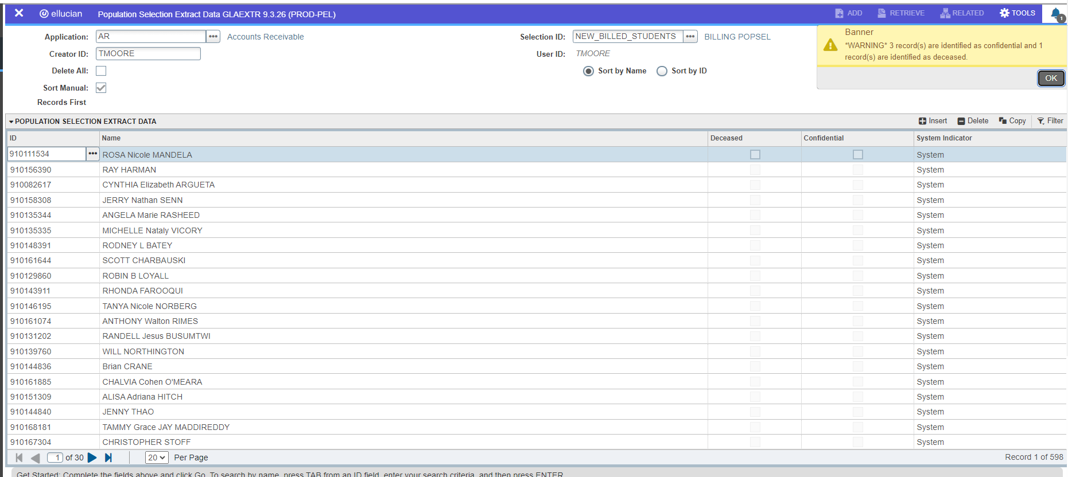

You will see you have 598 students (same as what was in your .log file.)

Next you will verify the data is correct.

If I look at my individual popsels BILLED_STUDENTS1 has 600 students and then I looked at my BILLED_STUDENTS2, it had 2 students. So this process founds my billing students which were not High School students and then removed the 2 bankruptcy students. (598 students)

You will want to very these students do have a balance and are not high school students and do not have a ‘95’ or ‘96’ loaded in TSAACCT.

Once you have verified your students you are ready for your letter process.

Go to GLBSEL

