1098T recipients who have a Citizen Code of either ‘NR’,’N’,UA’, or ‘OC’ and their PYRE>GRSH.

This population selection will help you find how many of your 1098T student have a Non Resident Alien code in Banner. It will only consider the student’s whose Citizen Code is either ‘NR’,’N’,’UA’ or ‘OC’ and it will only pull students whose 1098Ts PYRE>GRSH.
This can help you determine if you want to include your Non-Resident Alien students when sending out your 1098Ts.
In Banner go to GLRSLCT and setup the following population selection. You will need to save it and then hit the X button in the upper left hand side of your screen to compile it.
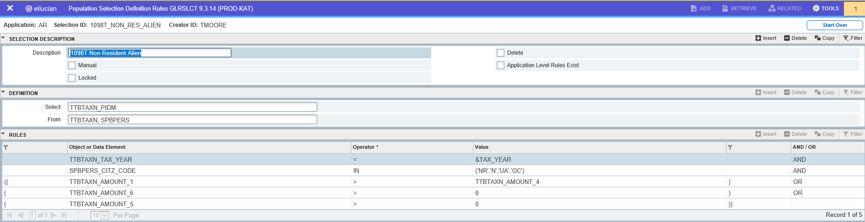
Once you have created, saved and compile you will go to GLBDATA and run the pop-sel.
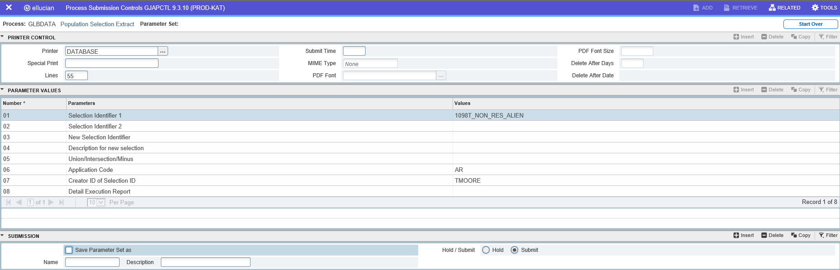

Review your log file. This will show you how many of your 1098T students are Non Resident Aliens. I have one student.
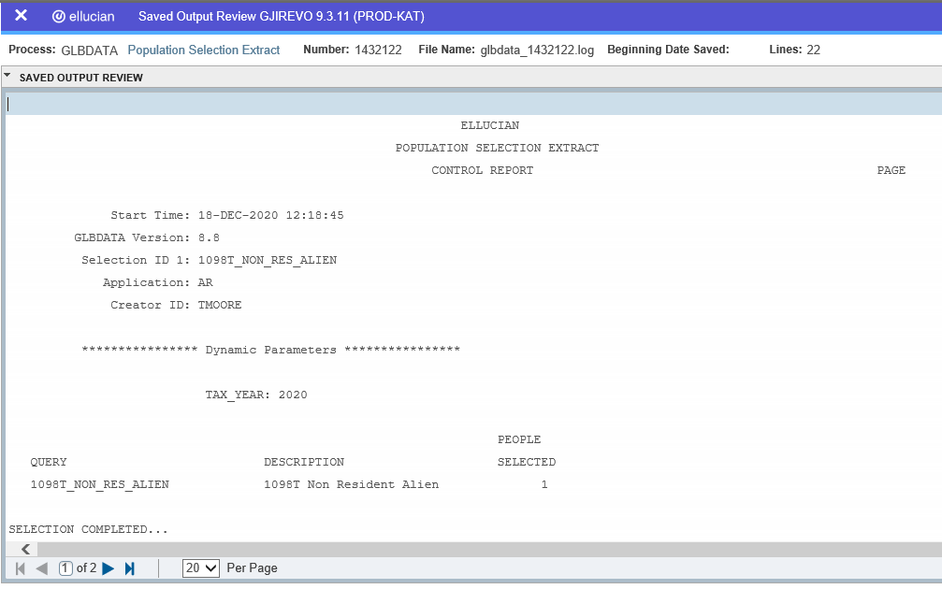
Now go to GLAEXTR to find who your students are.
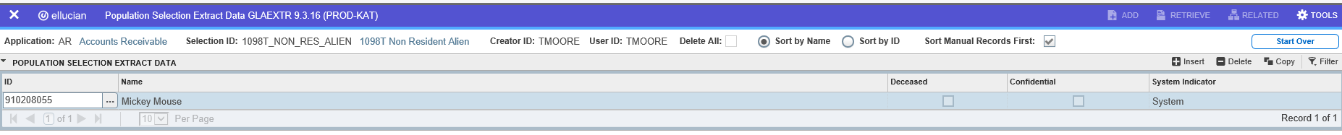
You will want to verify these students do have the Citizen Code of either ‘NR’,’N’,’UA’ or ‘OC’.

