End of Year
TGRRCON

DATA ON TGRRCON – Applied Not Fed - How do I find it?

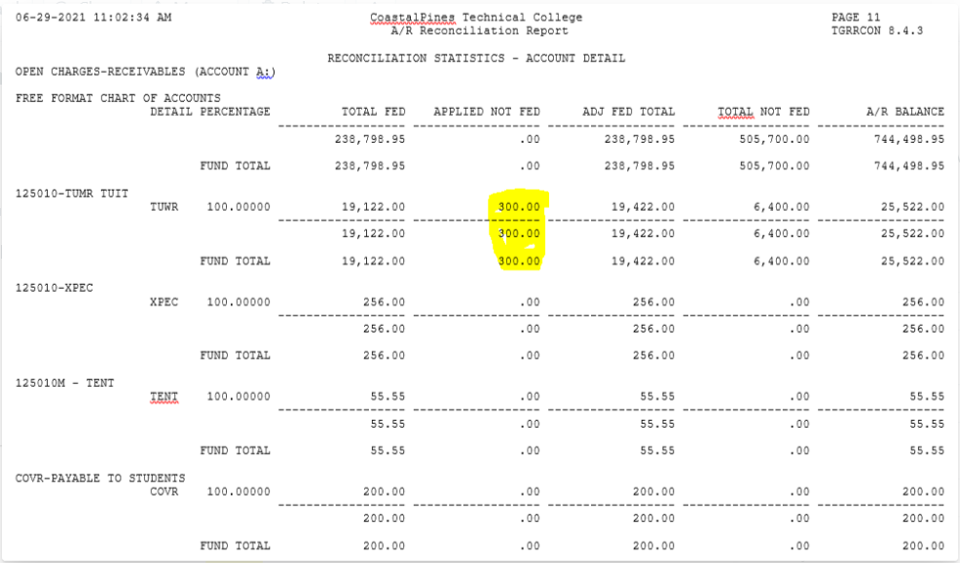

To find your student(s) that have been applied but not fed, go to TGIACCD hit F7 to filter, then add a new field and choose Feed Indicator from the drop-down. Then enter <> ‘F’ and hit F8.

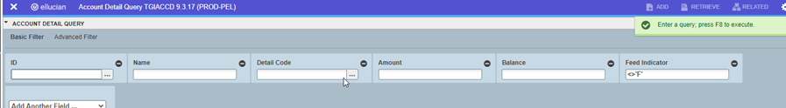

That should get you your list.

