Roll 1098-T Rules from year 2022 to 2023

Navigate to TSATAXR.
Enter QCB into the Tax Report Code box.
Enter 2022 into the Tax Year box. (You will copy your 2022 Tax Rule to 2023)
Then click Go or ALT+CTRL PGDN
Click Tools, then choose Copy Rules from the Menu.
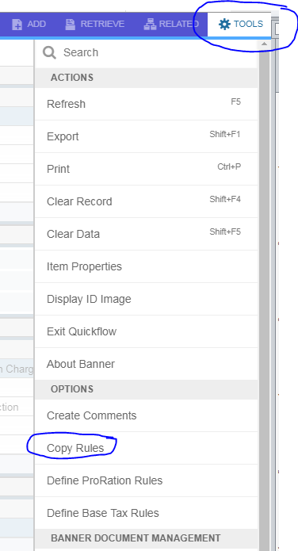
Enter 2023 in the Tax Year box, and Click Save.
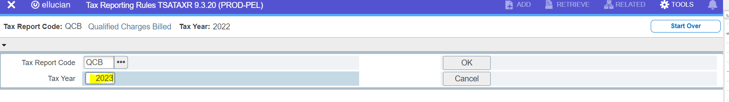

At this time, you have copied QCB rules from 2022 to 2023 and Banner has placed you in the 2023 rules. Now, update these rules reflecting new terms and applicable detail code changes.
- In the “Terms in Tax Year”, field change your terms. Delete all terms out of the boxes except for 202314. If needed, Uncheck future for 202314. Enter new terms for 202316, 202412 and 202414. Make sure future is checked for 202414. Click the Insert to insert new rows.
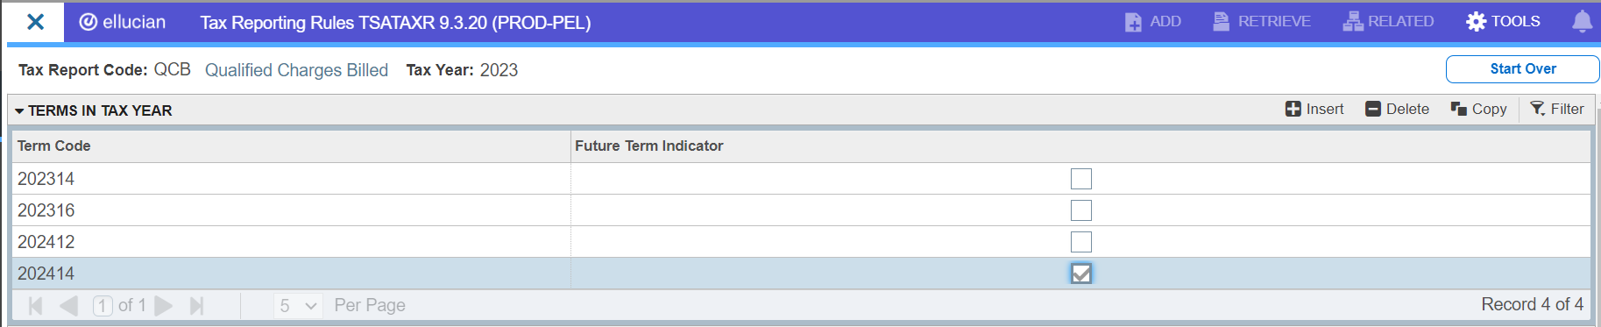

Verify the Tax Rules are as listed below:
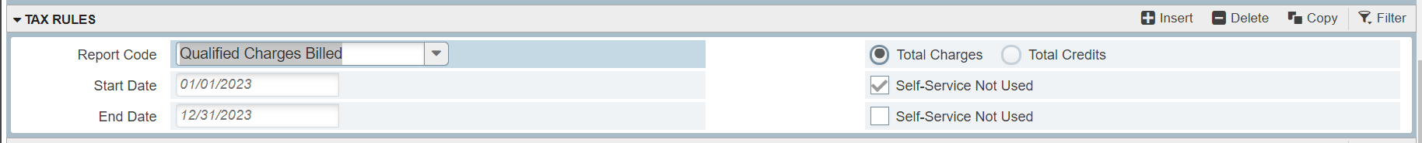

- Click into the category codes to include section and add any new categories. Most likely, you won’t have to add new categories because any new charges that have been added this year are probably already listed in the Category Codes section. Most likely, you should have no exceptions.
- In the Detail Code Exclusions within Category section, add any new exclusions that you might have for this year. These would include - INAC (insurance), INMP (mal ins), MISG (grad fee), MSCA (con ted grad fee), RCFE (return check fee), etc.
- In the Detail Code to Include Section, you may need to add associated fee waiver exemption codes for any of your new 2023 fees.
- If you added new fees this year they should be in the FEE category. But if you have new fee waivers for those new fees, those will need to be added since the category code is not the same and not in the category section.
Save this rule.
Repeat the above steps for rules GRSH. (Copy your 2022 GRSH rules from 2022 to 2023)
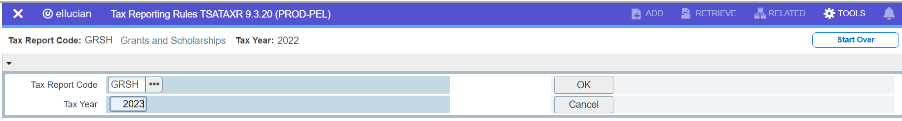
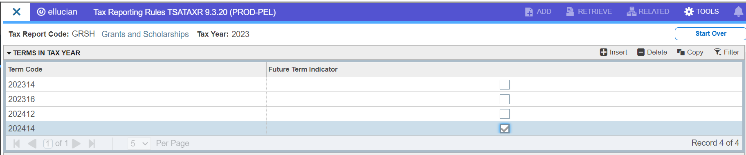

- For GRSH, “Terms in the Tax Year” are applicable but you most likely will not have any changes if the 2023 financial aid payment detail codes are within existing categories already defined. Check your REAC and HO30 detail codes to make sure they have the correct category. If they are not TRA, you will need to add those to your Detail Codes to Include rules for this year.
Repeat the above steps for rules PYRE . (Copy your 2022 PYRE rules from 2022 to 2023)
- 2021 Tax Year you will need to ADD STM and DOD to the category codes FOR PYRE since we will be including the CARES stimulus money in box 1 based on the guidance provided by the IRS and NACUBO.

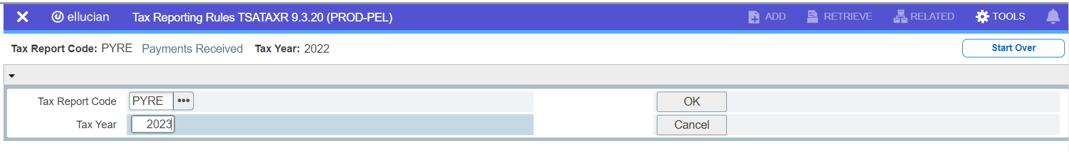
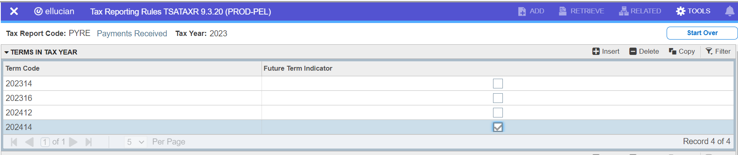

Make sure the Self-Service Enable 1098T box is unchecked. This box has been moved from the QCB rule to the PYRE rule since we are now reporting based on the payment method. So in late January, you will come to the PYRE rule to turn on 1098Ts for BannerWeb for students.
Check your category rules, any exclusion for the category, and any detail codes to include to this rule. Remember, this is ALL payments from ANY source except for those that must be applied to something other than Qualified Charges Billed. So this rule will combine your rules from your old PYMT and GRSH.
You will also need to make sure your refunds are added to this rule. Remember, regulations now state Payments for QTRE are the total amount of payments received for QTRE from ALL sources during the calendar year less any reimbursements or refunds that relate to payments received for QTRE during the same calendar year.
So if your refunds are in the RFD category, check to make sure that category code is there and you are done. If they are different categories, you will need to add each detail code in the detail codes to include section.
Make sure your CARES Act refunds are included here. They should be picked up automatically IF you set the category code to RFD when you did the setup on the detail code.
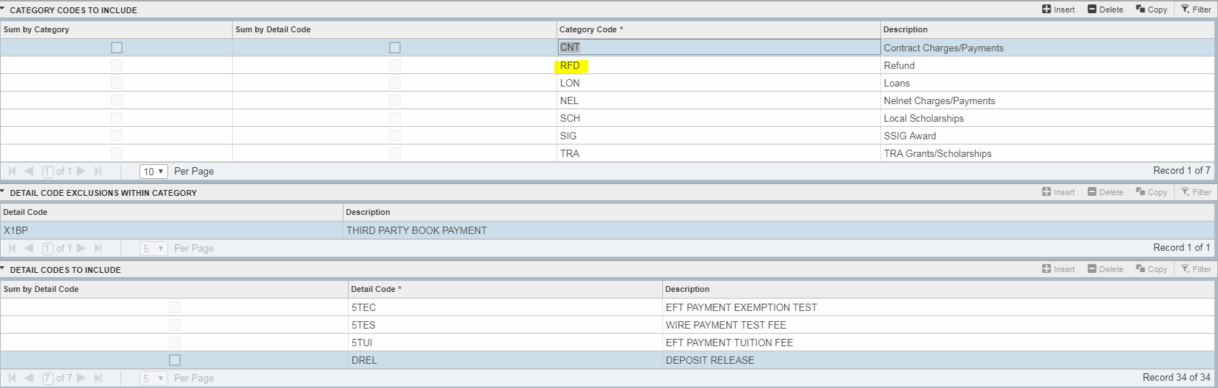
Finally, run process ZXRDETC to identify any new detail codes added in your system this year. Update QCB, GRSH and PYMT rules for the new codes.
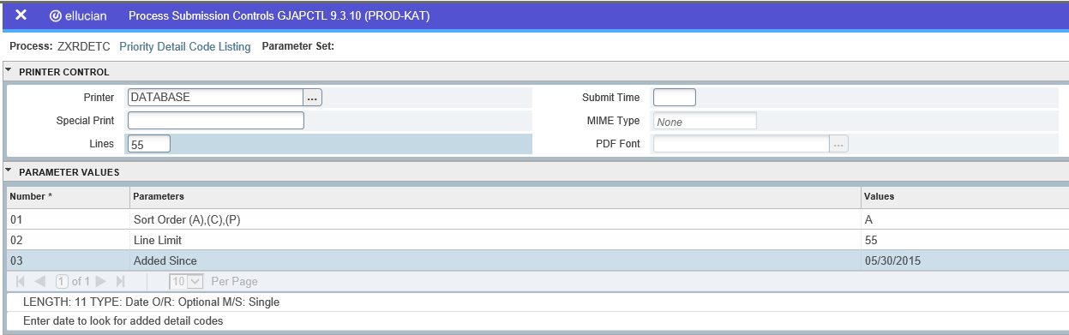
1098Ts report credit payments and charges only. No Continuing Ed charges and payments should be here. Exclude those charges and payments.
Vaccine Incentives SHOULD NOT BE INCLUDED IN ANY OF YOUR CATEGORIES. So those will need to be excluded from your rules either by detail code or category code depending on how you setup your detail codes.

