2023 Population Selections for 1098-Ts
All credit students will be considered over the last two years (due to adjustments in 2020).
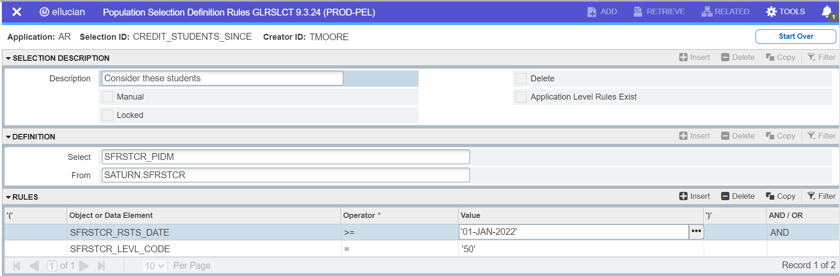

Required – This population selection identifies 1098T recipients with missing addresses.
Use this pop sel if you plan to exclude those who’s Grants and Scholarships are greater than Payments Received.
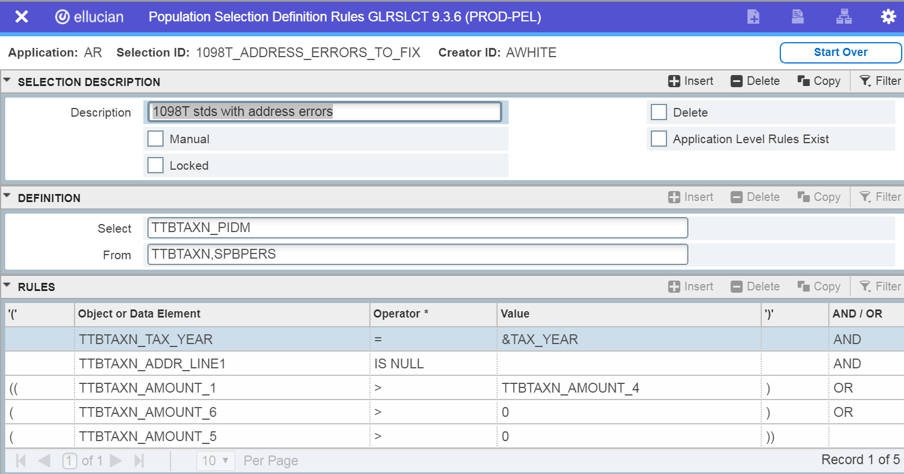

Use this pop sel if you plan to send 1098Ts to ALL students.
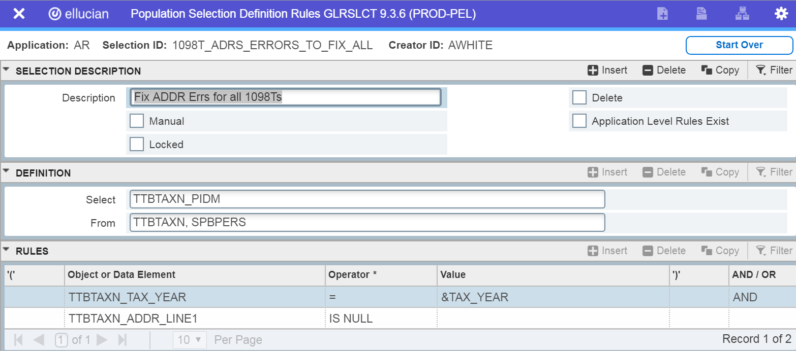

Required - This population selection identifies 1098-T recipients with missing SSNs.

Use this pop sel if you plan to exclude those whose Grants and Scholarships are greater than Payments Received.

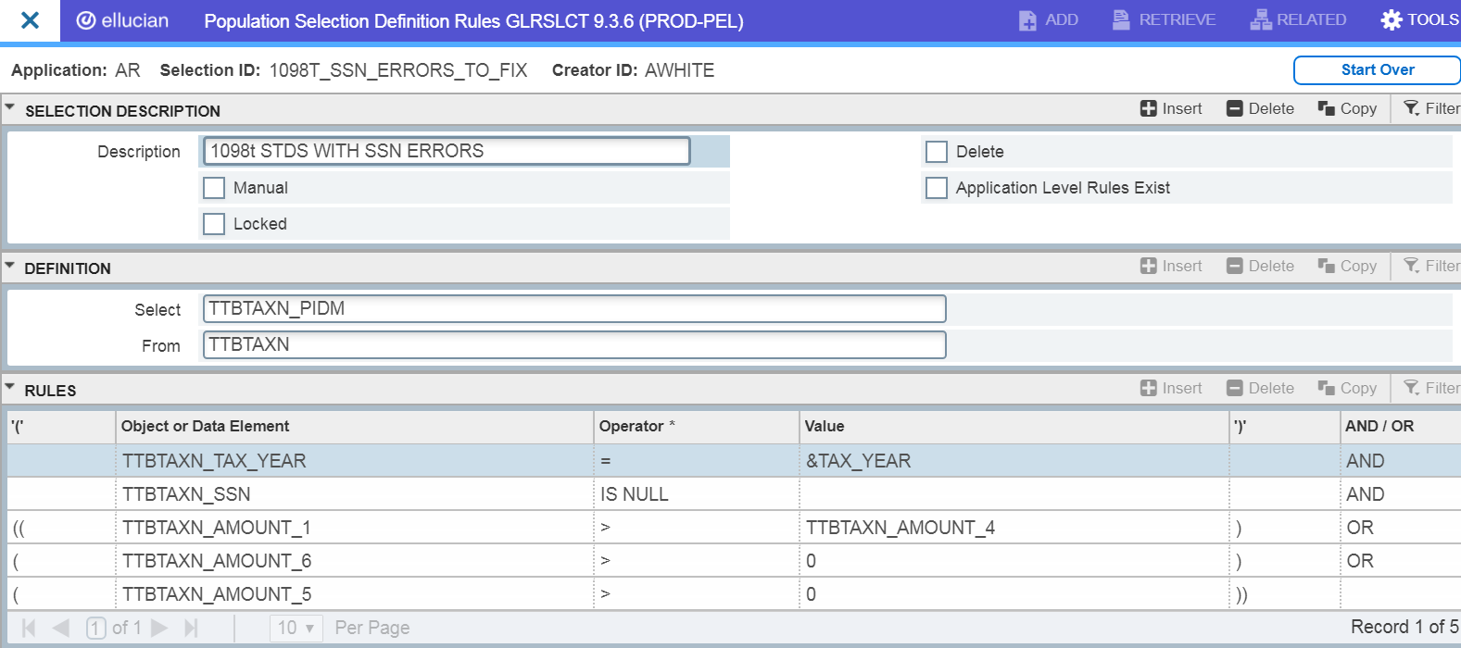

Use this pop sel if you plan to send 1098Ts to ALL students.
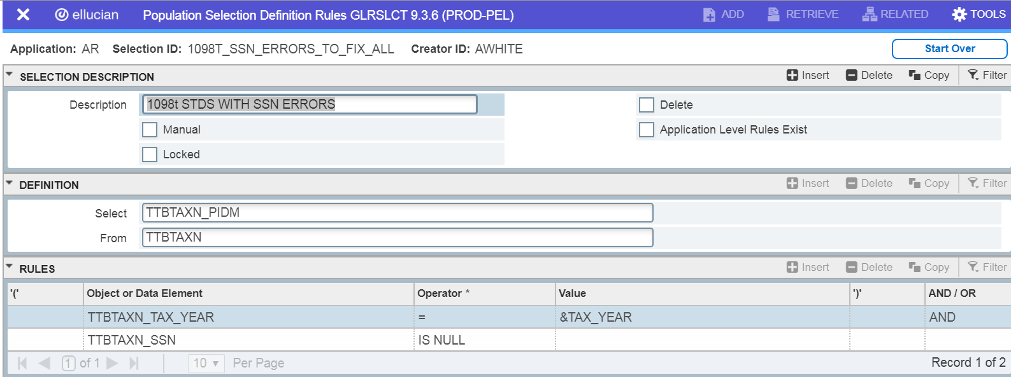

1098T recipients to be sent to ECSI. Use this population selection as input into TSR1098.

For those choosing to only send 1098Ts to those students that have PYRE>GRSH or have adjustments for previous years, use this pop sel.
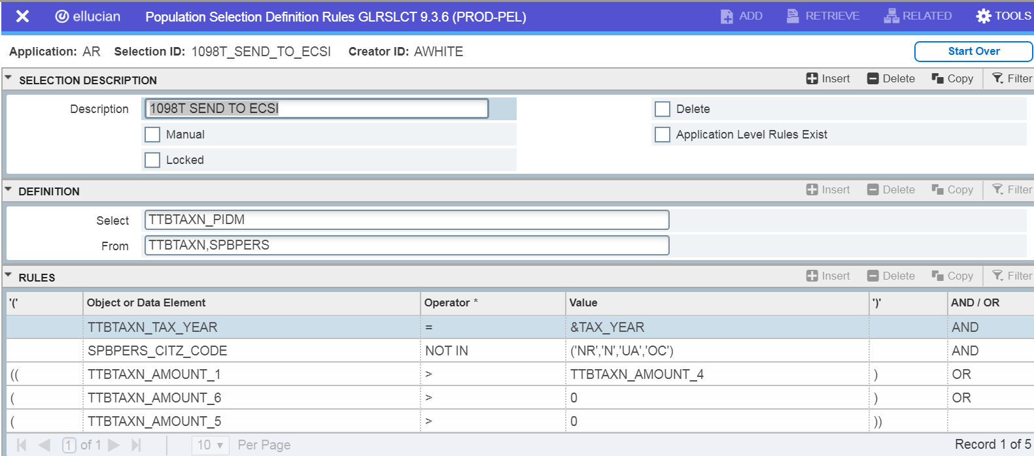

For those choosing the option to produce 1098Ts for students whose GRSH > QCB, then you will need to use this. This pop sel also includes non-resident alien students.
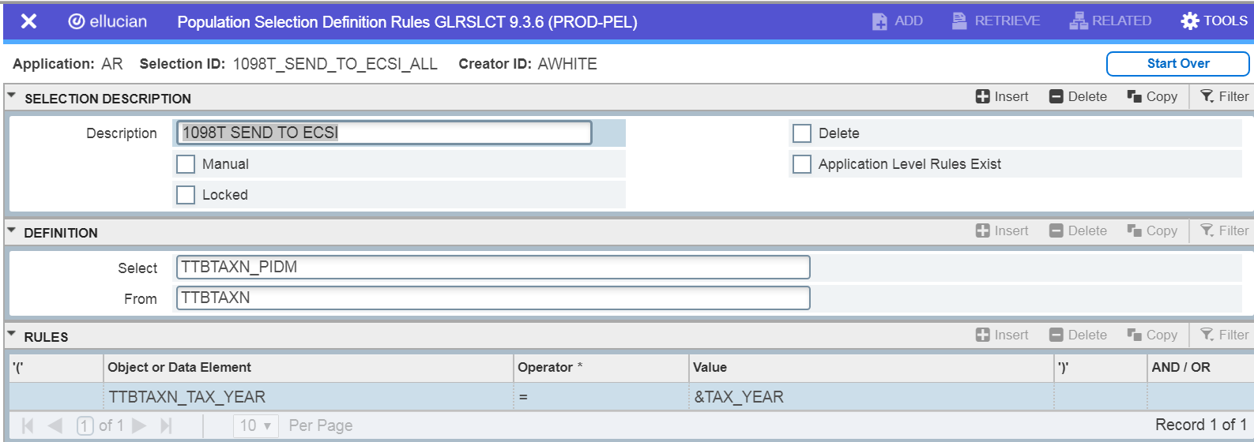
How to identify if you have missing SPAPERS records for 1098-T recipients
Set up these two population selections. After they are set up, refer to the next page on how to run these population selections. These two population selections will create a new population selection called VERIFY_THESE.
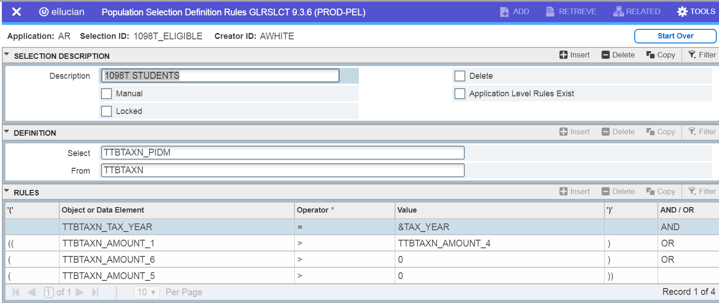

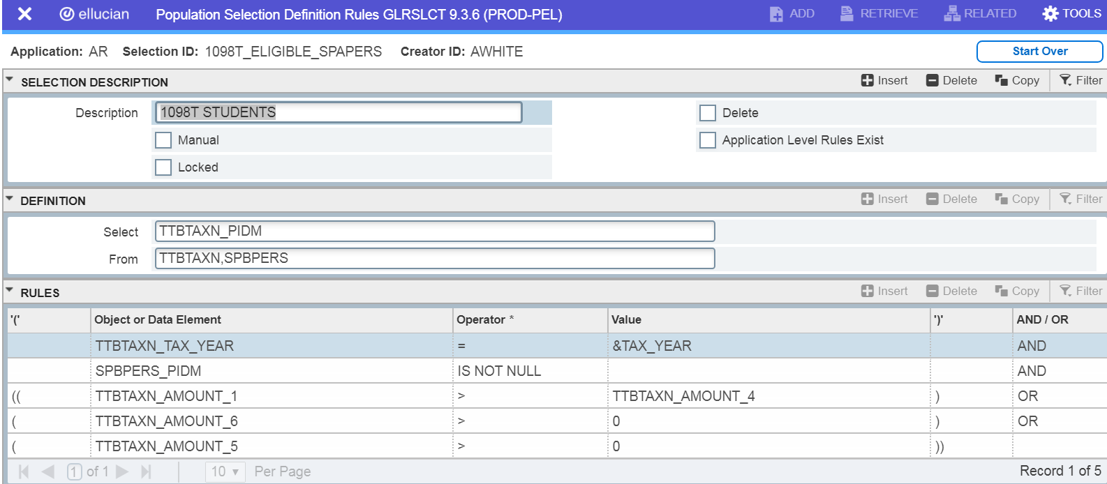
After GLBDATA is run, review the population selection VERIFY_THESE in form GLAEXTR.
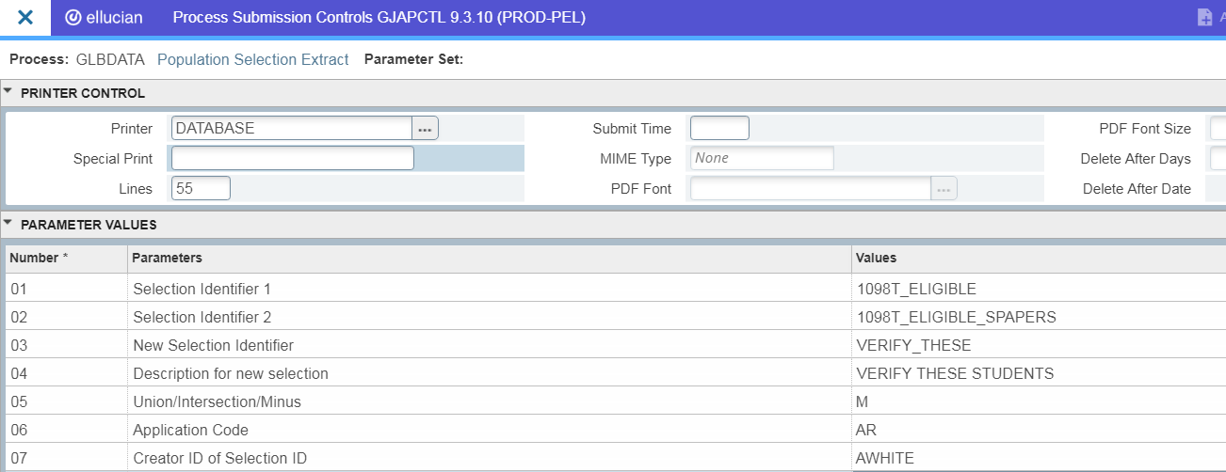

If you encounter students in this situation, a SPAPERS record must be created for these students and minimal information must be entered.

Getting a list of students that will be getting 1098Ts
This population selection will be used by those that are sending 1098Ts to students where their Scholarships and Grants are < Qualified Charges Billed. These pop sels should help in pulling students for desk checking and verification.
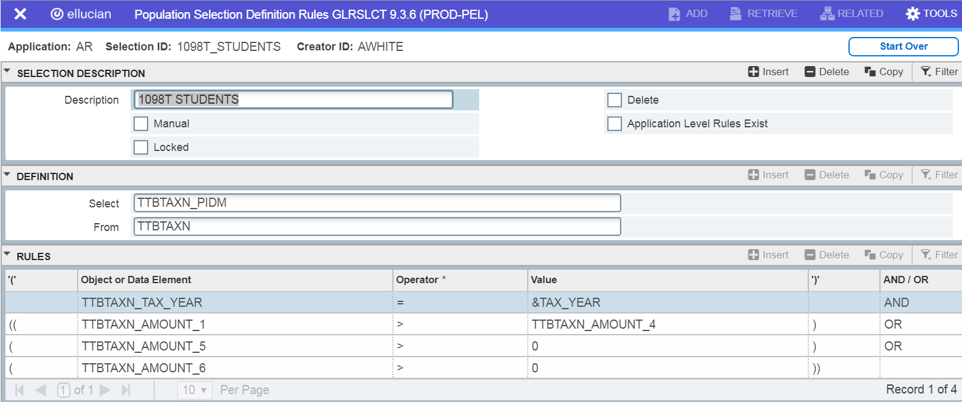

This population selection will be used by those that are choosing to send 1098Ts to students even though the students Scholarships and Grants are > Qualified Charges Billed. These pop sels should help in pulling students for desk checking and verification.
