1098T Processing Guide
- Go to TSA1098. Verify that the Transmitter Name is Heartland ECSI.
If your Banner page should looks like this:
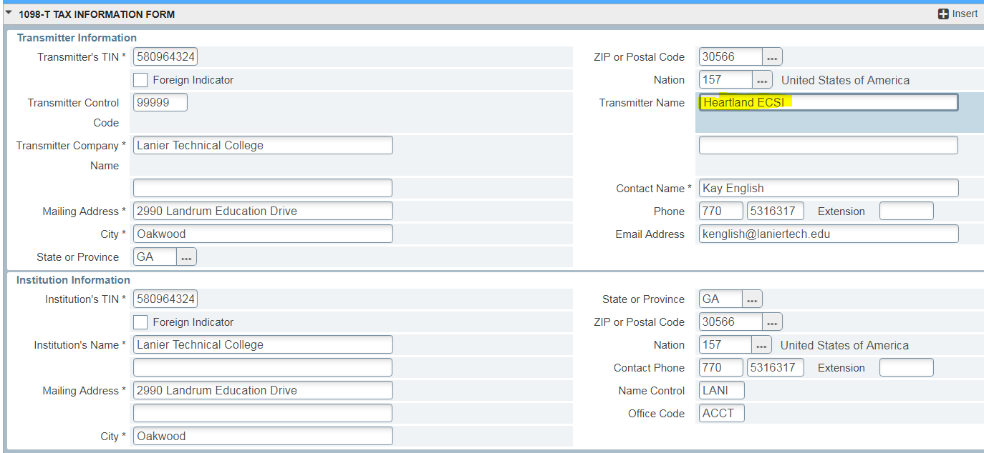
And hit F10 to save your changes.

- Run TSP1098 in TEST MODE to populate the TSATAXN form for the current tax year. This process may take a little while to run (see 2023_TSP1098_TSR1098_parameters doc for specific parameters).
If your college uses the CREDIT_STUDENTS_SINCE pop sel when running TSP1098, make sure to run GLBDATA with that pop sel BEFORE you run TSP1098. CREDIT_STUDENTS_SINCE is used to exclude continuing education students. If you college does not have con ted students in banner, then you do not have to use this pop sel. Make sure to update the date in the pop sel BEFORE you run GLBDATA.

- Run GLBDATA for 1098T_SEND_TO_ECSI (If your college excludes non-resident aliens and/or excludes students with GRSH > PYRE) OR 1098T_SEND_TO_ECSI_ALL (if your college is sending to all students).
- If your college uses this pop sel, make sure that you run GLBDATA before running TSR1098.

- Run TSR1098 in TEST MODE (see 2023_TSP1098_TSR1098_parameters doc for specific parameters).

- Review the .lis and .log files.
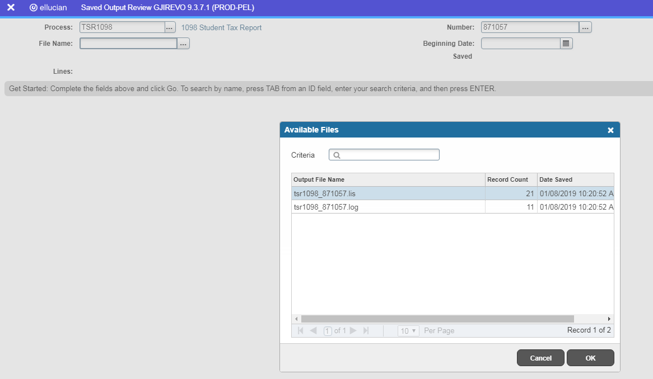

The lis file is not view helpful for us since we use a third party to process our 1098Ts. So this file will look a little funny because it is setup to be a printer file for printing your own 1098Ts. No useful data will be in this file for us.
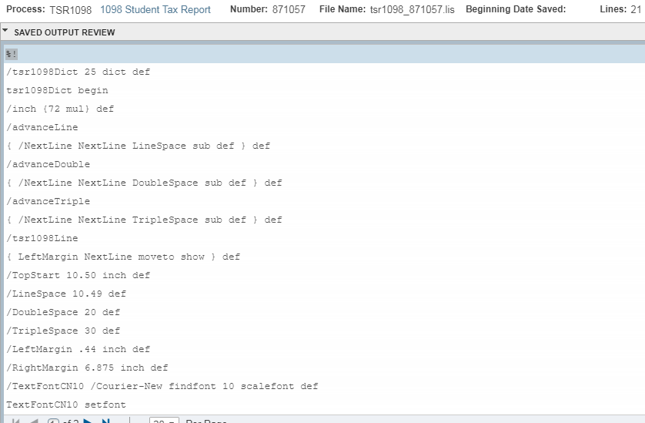
The log file will be helpful to us in data verification for the data file that we will be sending to the IRS. The log file will tell you if you have any errors. If you get a .map file error, please let Tracy or I know and we can send you instructions to send to your BPL to fix the issue and re-run.
It will also give you the # of 1098T forms printed for mailing. We do not mail our own, so this number will most likely be 0.
Total number of 1098Ts created in the tsr1098_XXXXXX file for electronic submission is important. This number should match a total that we will see in the data file that is going to be sent to the IRS. So you will need to make NOTE of this number.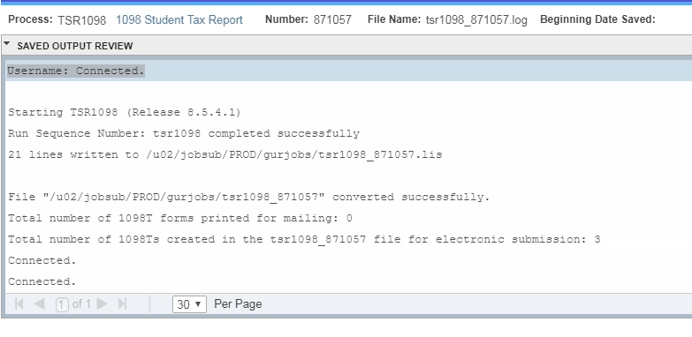

- Go into your BANNER SFTP process. Go to the /u02/jobsub/PROD/gurjobs directory and look for the tsr1098_XXXXXX (where XXXXXX is your job number). Then drag that file to your PC for viewing.
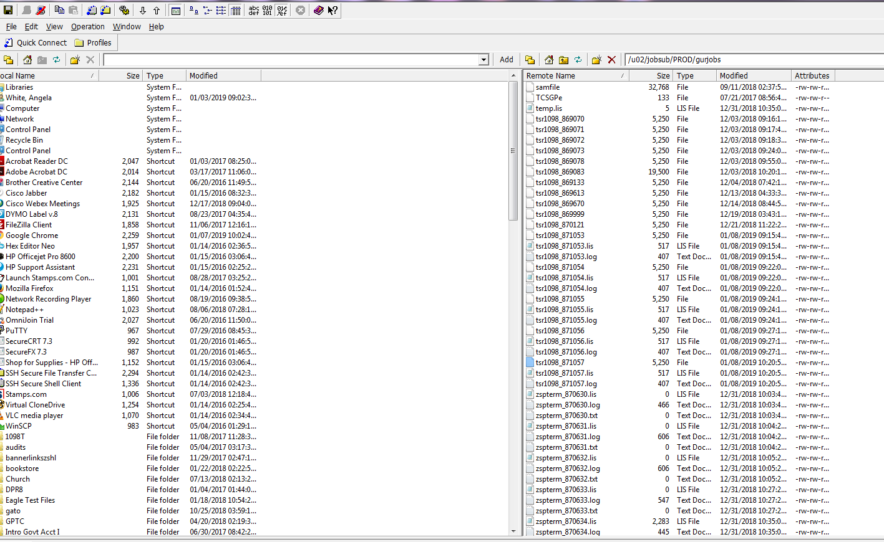
I moved mine to the Desktop. You can open in NotePad but if it looks strange close it and reopen with WordPad.
- Verify that the data in your file matches the information in TSA1098 and TSATAXN.
  - Verify that Transmitter Name that you changed on TSA1098 is the same in the file.
    - The Year will be whatever year you are running the 1098Ts for.
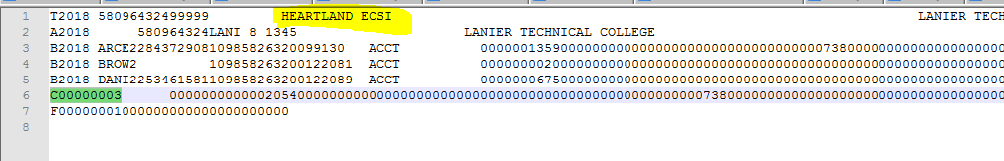
  - Verify the student data matches what is in TSATAXN.
    - The Year will be whatever year you are running the 1098Ts for.
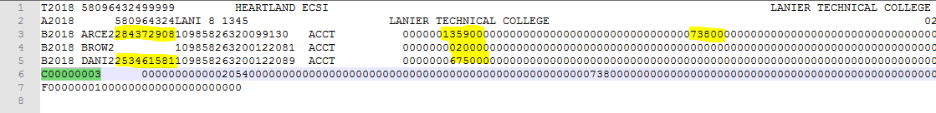
First Yellow highlight is the SSN. The second Yellow Highlight is Box 1 data. Third yellow highlight is Box 5 data. You will use these to verify that your tsr1098 data matches your TSATAXN data. The green highlight is your total 1098Ts being sent and should match the number from your log file.
FOR MORE INFORMATION ON THIS PLEASE VIEW THE Recorded Training Session.

