Setting up Cashier Restrictions

Once you have setup the user as a cashier – see Assigning a New Cashier to a Supervisor instructions – you can then give the user a category that contains detail codes that they can use.

You will also assign the Type of item they are allowed to enter.

P = Payments Only

C = Charges Only

B = Both Payments and Charges

But keep in mind that banner considered negative charges payments and negative payments charges.

In the example below, Tracy Moore is cashier that will be restricted.

1. Make sure the Restricted Box is checked.
2. Enter the Category Code that contains the detail codes that you want to allow the user to enter. If you are only wanting them to enter say DORM fees, then you might want to work with the business office to get that detail code set to a category code that only has that detail code assigned to it.
3. Enter the Type. P = Payments Only C = Charges Only B = Both Charges and Payments. If you are restricting this for audit purposes, then B would not be an option that I would use.
4. F10 to Save. Now the user will be restricted on what they can enter on TSAAREV and other T forms.

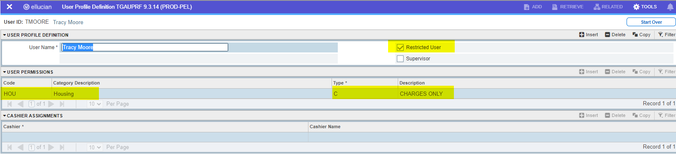

# So now let’s see it in action

I the HOU category on TSADETC there are only 2 detail codes. DORM and CAFÉ.

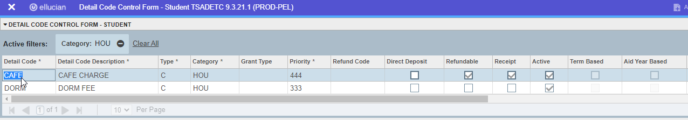

So in this scenario, Tracy is only allowed to enter Charges Only for DORM and CAFÉ.

So if Tracy goes to TSAAREV and tries to enter a TUIT charge, this is what she will get:

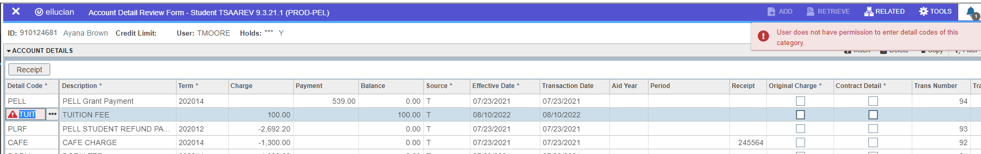

Notice it tells her she does not have permission to enter detail codes of this category and it will not let her save.

So this time Tracy enters a DORM charge:

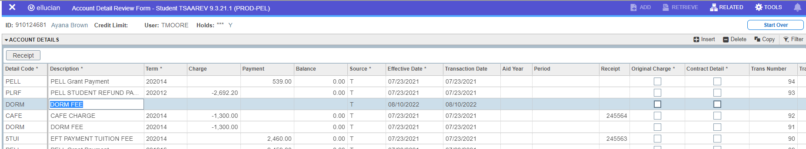

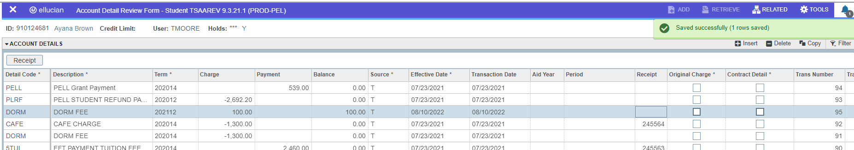

Notice there were no restrictions and she was allowed to save the record.

But notice what happens when she tries to reverse the DORM charge.

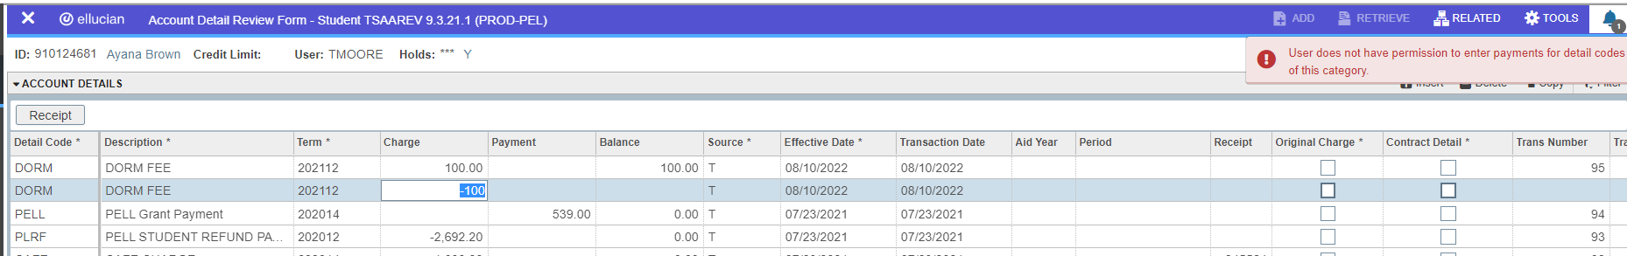 Because we set her type to C for CHARGES ONLY, Tracy will not be able to reverse her entry because negative charges in banner are considered payments and that is not a permission she has.