Assigning a New Cashier to a Supervisor
If you are trying to assign a new cashier to a supervisor, that users BANNER ID must first be setup as a cashier before they can be assigned to a supervisor.
So if you are trying to assign a cashier and get the error below, that means you need to setup them up as a cashier first.
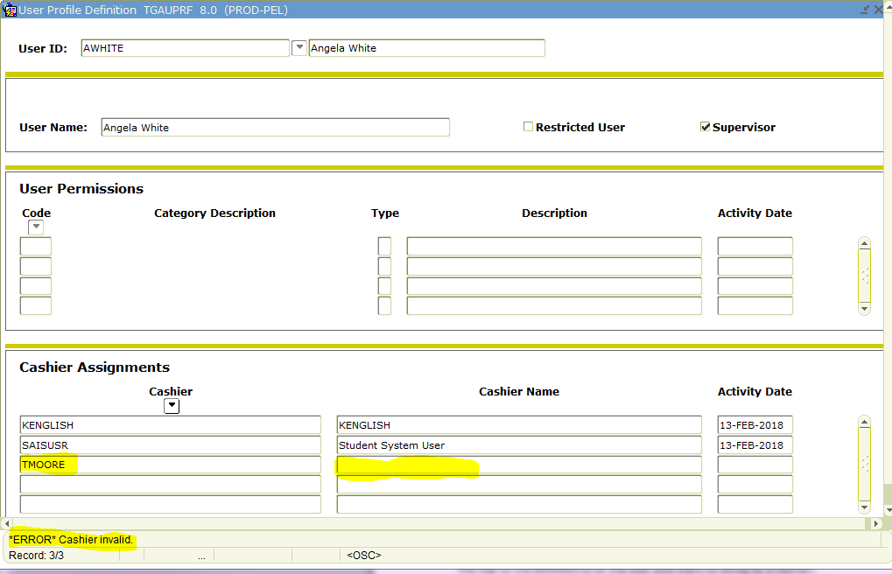

To setup a user as a cashier
First, you will need to rollback to the top of the TGAUPRF form. Then change the ID in the User ID box at the top to the BANNER ID of the user you want to setup as a cashier.
Then control+pgdn and type the user’s first name and last name in the User Name box. If the user is a Restricted User, then check that box. If not, then do not check the box and save to record(F10).
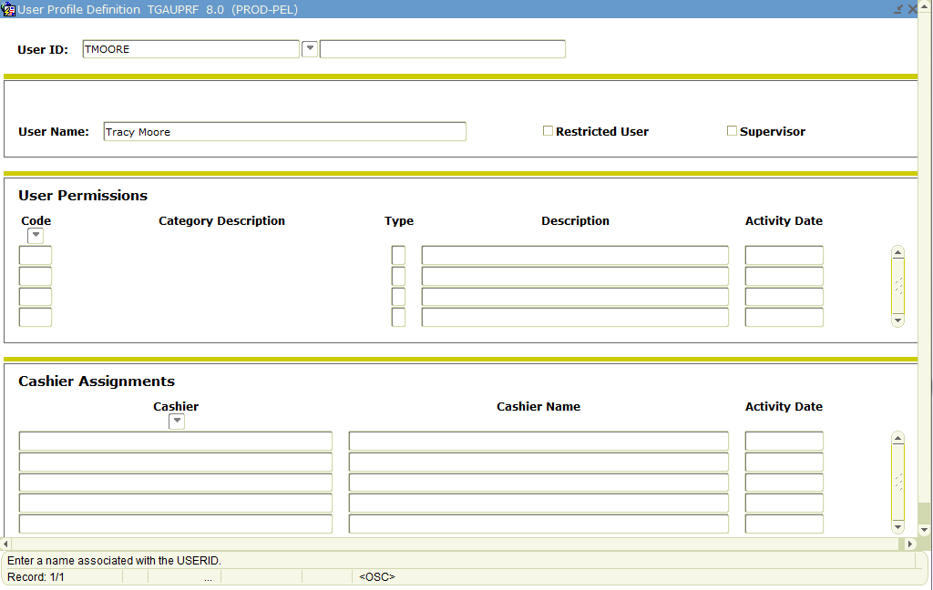
Then rollback to the top of the TGAUPRF form, and enter your BANNER ID back into the User ID box and ctrl+pdgn until you get back into the Cashier Assignments section.
Then you can enter the user’s id into the cashier box and save the record (F10).
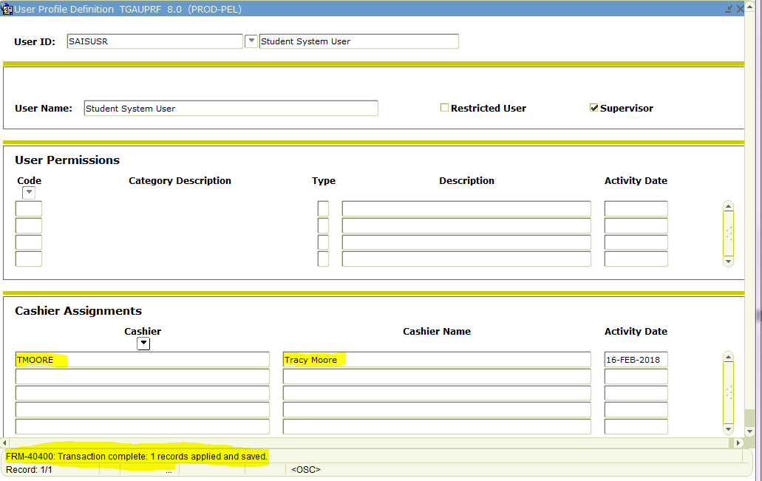
The cashier is now assigned to the supervisor and the supervisor can now update the status of the user’s sessions and make correction to that users sessions if needed.

