TECHNICAL COLLEGES
BANNER PROCEDURES MANUAL

This procedure applies to Technical Colleges

ESTABLISHING BOOKSTORE TO BANNER INTERFACE PROCEDURES

General

This interface was implemented in order to transfer TCSG college bookstore’s charges from the Nebraska Point-of-Sale (POS) system into Banner. In order for colleges to benefit from this system, the college must have implemented either the PRISM or Win PRISM POS and AR systems.

A cron job (a script written to systematically perform a sequence of events) was written by the Director of System Development & Support at TCSG to transfer bookstore sales once all the bookstore registers have been balanced and all bookstores closed for the day. There are two software packages available from Nebraska Book Company that allows this process. The software packages are Win Prism or Prism.

The software for the interface is loaded on your Banner Box. When implementing this software for the first time, security scripts need to execute which provides the proper permissions for the three Nebraska interface menu options. The Banner Project Lead should contact Enterprise Services or the Director of System Development and Support for further information on a new installation set up.

Win Prism
The Banner Project Lead (usually IT) should contact the Technical College System of Georgia’s Director of System Development & Support for access to the script to implement Banner processes.

The Win PRISM system has functionality to handle cron jobs and automatically load data or transfer data to Banner. It is recommended to run “Banner to Bookstore” and “Bookstore to Banner” in the cron. This allows the college to schedule these processes automatically and eliminate “operator intervention”. The Banner Project Lead at each College can adjust the cron job for the appropriate time for that College. For example, some Colleges begin the cron job at 11:59 pm. It is imperative that all register sessions and bookstores are closed at all campuses before this process begins.

The next morning the Bookstore Manager should email the A/R Sales from the previous day (data from AR Reconciliation Report) to the AR Supervisor or designee. The AR Supervisor or designee should go in Banner to TGACREV(Cashier Session Review Form) to verify that all of the A/R Sales from the previous day sales transferred into Banner correctly. Note: Departmental sales and Credit Memos can affect the totals.

Prism

The PRISM system does not have functionality to handle cron jobs and automatically load data easily. It is recommended to run “Banner to Bookstore” from the DTAE/TCSG menu. Because the “Bookstore to Banner” process can be done once a day, this process can be set up in the cron.

In Prism the following step should be completed every morning to process the previous day sales to Banner. Prism users should go into Secure Shell and select the appropriate Profile tab. The drop down menu should have the name that was established by the Information Technology (IT) team. Once the appropriate tab is selected a screen will come up and require a password provided by IT. If a menu does not appear, type “menu” at the prompt.
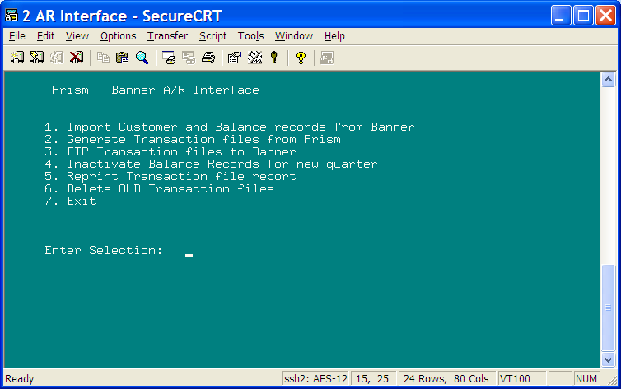

#2 – Generate transaction files from Prism

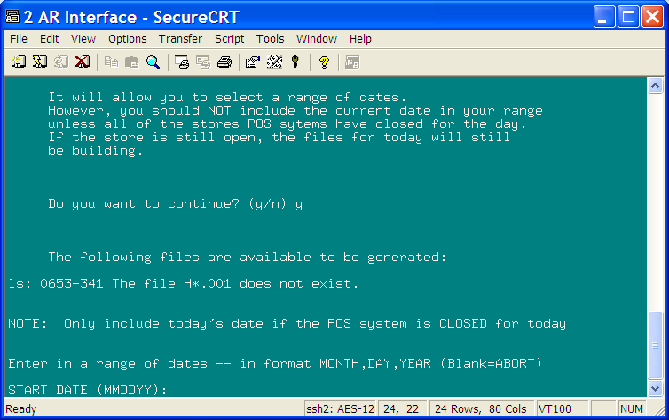

Do you want to continue? (y/n) Y

The following files are available to be generated:

H012204.001

Enter date (MMDDYY) and enter: 012204 (enter)
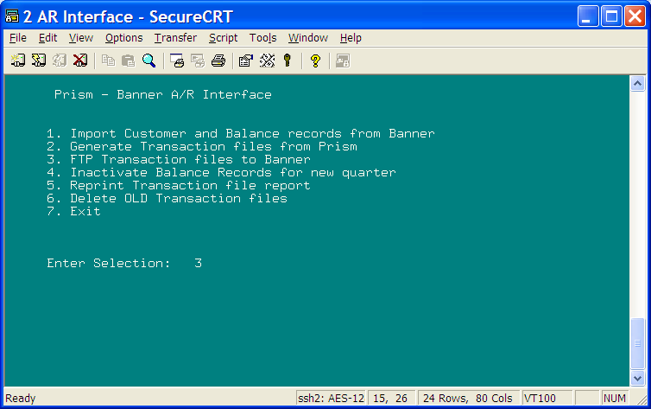
#3 – Copy transaction files to Banner

Do you want to continue? (y/n) Y
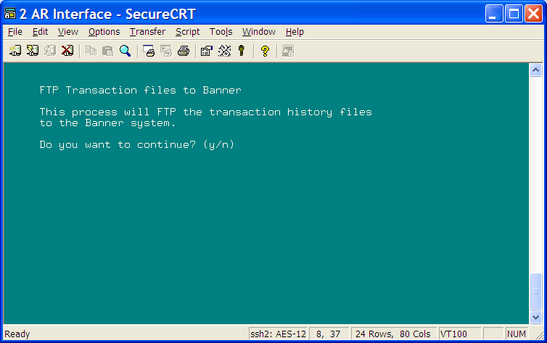
Enter
Enter
7 – to exit
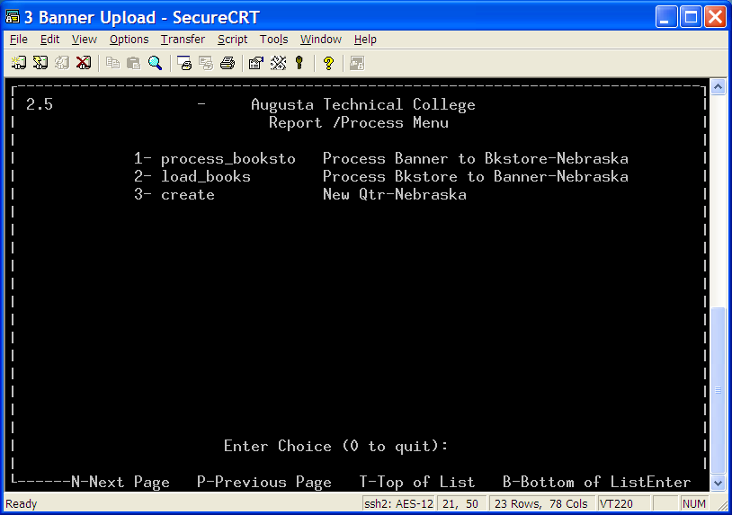
#2 – load books

Press “Enter” to return to main screen

“0” to quit

Exit

