Administrative Services
BANNER
GUIDE
Administrative services
Processing Student Checks

Table of Contents

Balancing the JV Report 1

Processing the Checks 6

Processing the Check Register 14

Balancing the JV Report
The purpose of balancing the JV report is to help you determine the amount of fees due to the college, the receivables in Banner and to verify the total dollar amount of each check run.
- First login to Banner with your username and password. (Your sign on may look different than the one listed below)
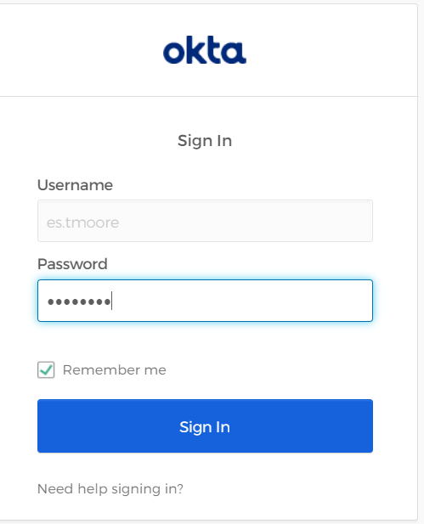

2. Once you have connected you will be brought to the landing page, from there you will need to enter in ZSRJV01, as instructed on the screen below and press enter.
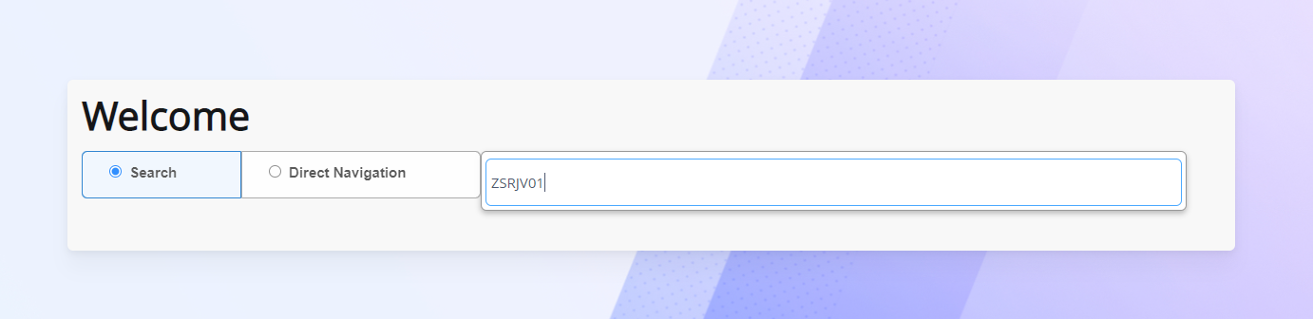
The JV Report (ZSRJV01) is a report of all application of payment by time frame.
ZSRJV01 is a job-submission report currently with 18 parameters. ZSRJV01 prepares a report of all application of payments by the selected time frame (term or date-driven). ZSRJV01 reports JV information for purposes of balancing student accounts and for justification of booking into PeopleSoft.
Student Receivables will not appear on this report. This process reports on all application of payments if the payment/charge is included within the selected time frame using the selected report variables. The option to generate a TXT file is also available.
If application of payments is accurate, receivables can be reported accurately in other reports.
The JV report can be run four different ways. You can run the report by Detail, Negative, Specific or Summary. The instructions below will show how setup and run all four reports.
You can setup these different parameter sets. It can help you find whatever you are looking for or needing the JV report to pull at the particular time you are running the JV report.

Below are the basics for each selection, but you will need to change these based on your college’s needs.

For Detail: you will enter your term/date parameters, aid year (which can be %), etc. But Parameter 07 will be an N. This will print students and totals.

If Y is entered for parameter 07, only summary totals print.
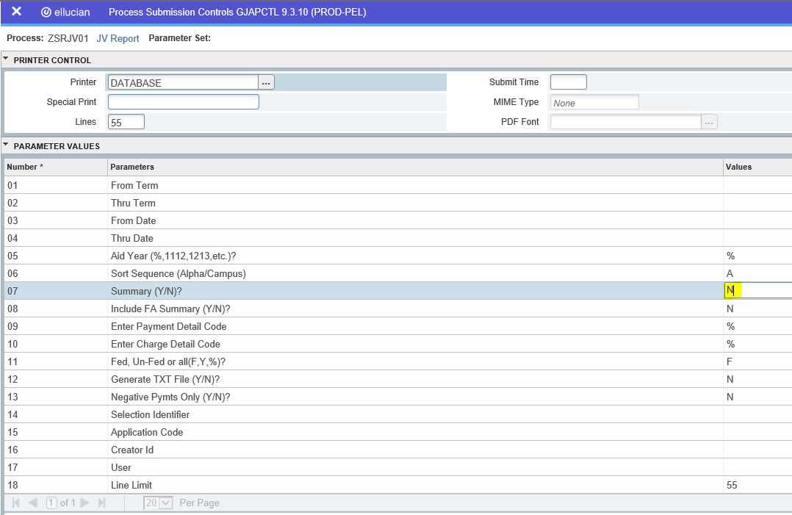
You can save each of these different types of JV Reports by Checking the “Save Parameter Set as” box and giving it a Name and Description as shown below.
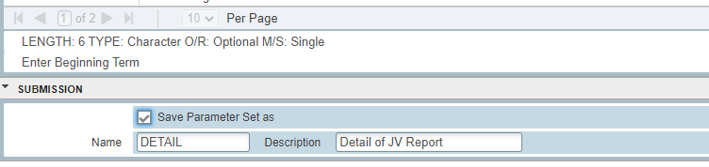
For Negative: you will enter your term/date parameters, aid year (which can be %), etc. But parameter 13 will be a Y. If this is Y only negative application of payments will print on the FA Recap. This is the only way to see activity that might need un-applying and re-applying. The default is N (Show all activity). This parameter will allow you to correct application of payment problems easily.

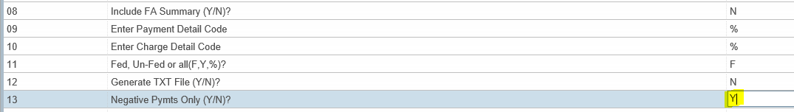
For Specific: you will enter your term/date parameters, aid year (which can be %), etc. But parameters 09 and 10 will have the detail codes entered that you want to specifically look at.

Enter Payment Detail Code: This parameter defaults to % but you may change it to a specific payment detail or a partial detail code. Valid entries include but not are limited to: %, H%, HO%, HO50, PELL, etc.

Enter Charge Detail Code: This parameter defaults to % but you may change it to a specific charge detail or a partial detail code. Valid entries include but are not limited to: %, H%, HO%, HOCL, HOPR, PLRF, etc. You can also find if any payment detail codes are reversing entries. You could enter HO50 here. It would tell you if a 3TUI has married up to an HO50. In combination, these two above parameters are very powerful in determining invalid marriages.

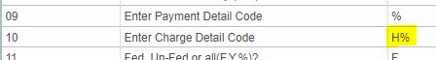

For Summary: you will enter your term/date parameters, aid year (which can be %), etc. But parameter 07 will be Y. This will print summary totals only. If N is entered for parameter 07, students and totals print.

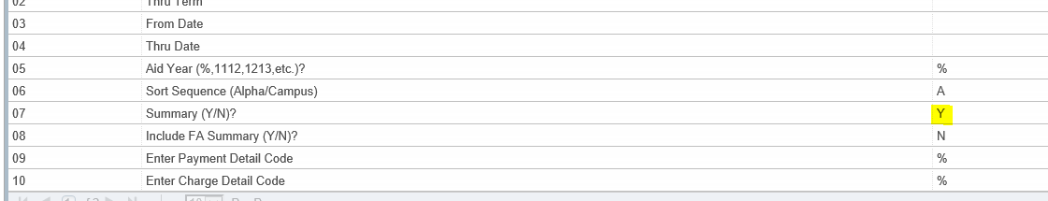
3. Go to ZSRJV01, this screen, enables you to run the JV report. Follow the steps listed below to run the process:
- If you have setup the different Parameter Sets, you can click the … box beside the Parameter Set to select which one you want to run.
The following will appear.
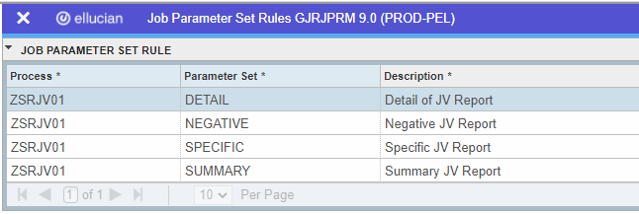
Make your selection by clicking on the Parameter Set then click the Select  button on the lower right corner of your screen.
Onced you have made your selection, press the Go button.
If you do not have different Parameters Setup You can simple run the JV report with the parameters you enter. (Enter ZSRJV01 on the landing page and then select Go.)
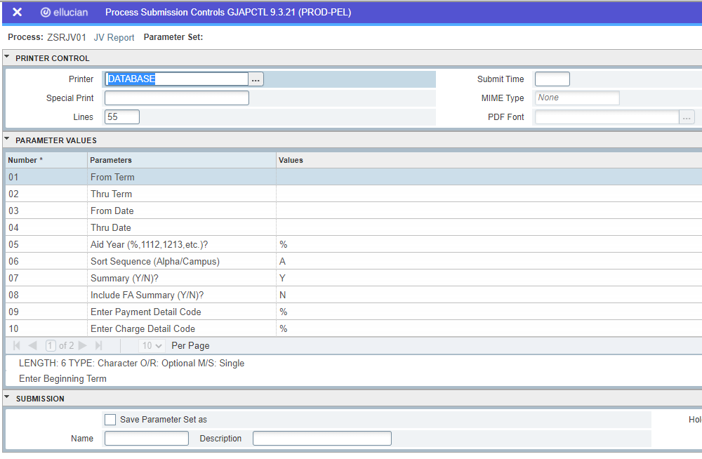
Enter your paramerter values.
A Detail JV report will allow you to see exactly which detail codes are married together.
A Negative JV report will allow you to see which detail codes are married up incorrectly
A Specific JV report will allow you to enter in the detail code you are looking for; you will need to fill in parameter #09 by typing in the detail code
A Summary JV report will give you a summary of figures for each detail code for a given term or for the year

Instructions for balancing the JV report:
When balancing the JV report, you first need to look at the Totals Summarized. You should make sure that the Payment detail code is married up with the correct Charge detail code. In the event two detail codes are married up incorrectly, you should then run the Negative JV or the Specific report to find the students. Once you determine who the students are then you can un-apply and re-apply the term where the detail codes are married up incorrectly.
Once you have determined that all detail codes are married up correctly, you can then run a Summary JV report, by summary you will be able to determine the true balances for each detail code and you will be able to determine the dollar amount of checks you will need to process.

Processing
Refund Checks

Now that you have balanced the JV report and you have identified the dollar figure for your checks, you are now ready to start running the program that processes the checks.

ZSRRFND – Student Refunds (Job Submission)

ZSRRFND generates student refunds in job submission. Refunds can be generated by either TERM or FISCAL YEAR. If generated by fiscal year, the program will still determine the refund by each term code within the fiscal year. Either Term Code OR Fiscal Year must be entered. The process can be run in either an AUDIT mode or an UPDATE mode.

Note: When processing the refund checks, you need to run each term/fiscal year separately and in the sequence noted: Term, HOPE GED, SWIG, Cash Refund, SEOG, etc.
You will also have to balance after processing each check run type.

- To begin you must first run the process that will place the refund code on the student account. This will allow the refund to marry with the code with the credit balance. Type in “ZSRRFND” on the landing page. Then press “Enter”.
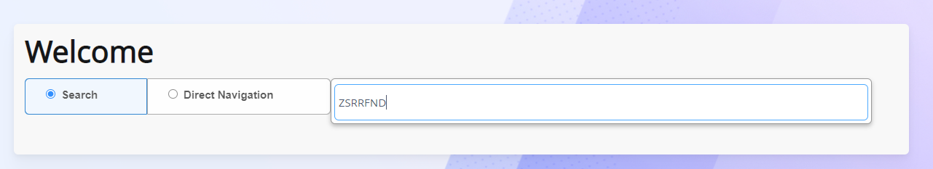
The following will appear, Then press the Go button.
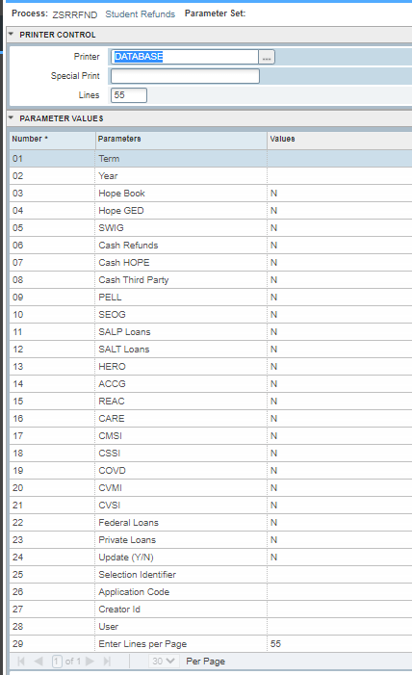
- Once the screen appears, you will need to enter DATABASE in Printer Control section.
Enter either Parameter 01: Term – Type in the term for which you are processing refunds, or Parameter 02: Fiscal Year - Type in the fiscal year for which you are processing refunds.
Parameters 03 through 23: - Enter a Y in the parameter you are wanting to process checks for those funds. Leave the parameter set to N if you NO NOT wish to process checks for those funds.
Parameter 24 – Update (Y/N) – Always run in Audit Mode (N) first to verify your data. If correct run in Update Mode (Y)
Parameter 25 – 28 You can use a population selection information if you wish to run checks only on students that are in your population selection.
Parameter 29 (Enter Lines per Page) can be left to 55.
Alt + page down into the Submission Box, then Click the Save button on the lower right side of the screen to run the process.
Review your .log and .lis file. Make sure you do not have any errors and your data is correct.
Once the ZSRRFND report prints, verify that the totals on the report equals the dollar amount on the JV report.
If the totals do not match, you will then need to go back to step 1 in balancing the JV report. You may need to repeat balancing and the ZSRRFND process steps several times until your figures are balanced.
Once you are balanced, you will need to run the ZSRRFND process in update mode.
- You will follow all of the steps from instruction #2 and you will also complete Parameter Value “24”, replace the “N” with a “Y” to run in update mode.
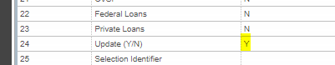
Alt + page down into the Submission Box, then Click the Save button on the lower right side of the screen to run the process.
Review your .log and .lis file. Verify your data is correct.
Once the updated and verified ZSRRFND report prints, you will then need to run the application of payments process “TGRAPPL”. When the TGRAPPL process is complete, you are now ready to run the check register. Note, when running the check register process, you will run it in audit mode first to make sure it too balances with the ZSRRFND and JV report. Once you have balanced the check register, you will then run it in update mode.

Generating

The

Check Register

ZFRCHEK – CHECK Writing Program

ZFRCHEK is a job-submission process that generates registers, checks, and ACH files for student refunds. If the college uses BankMobile, the check register is read after the update to create the BankMobile refund file. ZFRCHEK is run from Banner screen GJAPCTL. ZFRCHEK can generate checks for both persons and non-persons. This process produces a check register, optional check lists, optional ACH transaction lists, optional debit card lists, and updates the check date and the check number on TSAAREV. ZFRCHEK doesn’t actually print checks but generates the formatted check files for input into the Capella Pressure-Seal software. ZFRCHEK includes selections to print an audit (proof), an audit (proof) with errors only, and an update (a live check run) features.

It is CRITICAL that when you perform a check run that it is run twice – one for BankMobile recipients and one for non-BankMobile recipients (parameter 26 = Y, then run later with N).

Students may obtain refunds from a check, a BankMobile file, or an ACH to their bank. Once ACH files have been processed, make sure you remove the PACH* files from the Banner system.

ZFRCHEK processes refund checks for the following check types: Cash refunds, SWIG, GED, PELL, SEOG, SALP, GSAL, Hero, ACCG, REAC, CARE, CMSI, CSSI, COVD, CVMI, CVSI, Federal Loans, Private Loans, Law Enforcement, COGP, IASG and ARRA, The refund detail codes associated to these check types include 4%, SWIR, HOGR, PLRF, SEOR, HERR, ACCR, LEPR, LOUR, LOSR, COGR, IASR, ARRA, REAR, GSAR, GSLR, CARR, CMSR, CSSR, COVR, CVMR, and CVSR.

Currently, the maximum check dollar amount that can be generated is $9999.00.

- To print the checks, on the landing page enter ZFRCHEK and press Enter
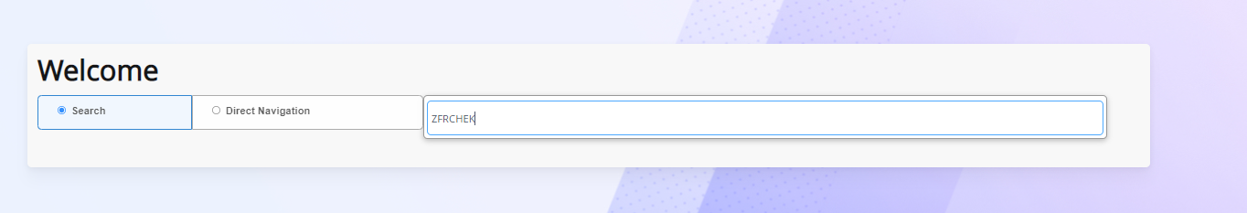
The following will appear, Then press the Go button.
Once the screen appears, you will need to enter DATABASE in Printer Control section.
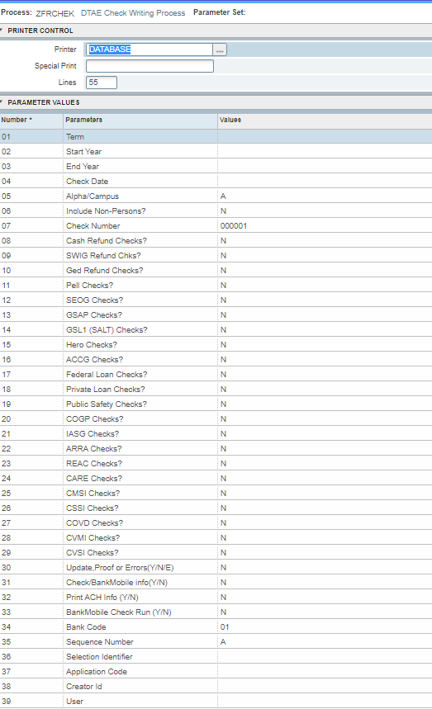
Enter either Parameter 01: Term – Type in the term for which you are processing checks, or Parameter 02: – Start Year and Parameter Value 03 – End Year
Note: Do not enter a Term and a Year. The program defaults to Term if this occurs. The End Year Must be within 3 years of the Start Year.
Parameter 04: Check Date – Enter the date of the check (Format DD-MON-YY)
Parameter 05: Alpha/Campus - Enter a value of A for Alpha or C for Campus
Parameter 06: Include Non-Persons – If the value is Y, both Person and Non-Person accounts are considered. If N is entered, only student accounts are considered.
Parameter 07: Check Number – Enter the starting six-character check number.
Parameter 08 – 29: (Cash, SWIG, Pell checks, etc.) Change the N to a Y to have that type of refund to be considered.
Parameter 30: Update, Proof or Errors (Y/N/E) – You may run this process in Audit Mode (N ) Audit or Proof (E) Audit or Proof and only informational and error messages, Update (Y) a live check run.
Parameter 31: Check/BankMobile info (Y/N) – Behind the “all inclusive” sequence check register, you may bet an optional report of Checks only. If you enter Y a list of students will pring in check number sequence.
Parameter 32: Print ACH Info (Y/N) – Y to get a list of students in ACH transaction number sequence.
Parameter 33: BankMobile Check Run (Y/N) – If this value equals Y, only checks for students with entries in SEAASGN will be selected. If your college does not use BankMobile, this value must always equal N. Note: If the college uses BankMobile, process ZSPCREF must be run immediately after ZFRCHEK has ran in update mode.
Parameter 34: Bank Code – For ACH processing, this parameter must be the Bank Code set up in GXRBANK.
Parameter 35: Sequence Number – For ACH processing, you have to specify the sequence number. If this is your first check run for the day, enter A. If this is your second run for the day, enter B, etc.
Parameter 36 – 39: Leave these parameters blank if not using a Population Selection. If you are using a population selection these parameters must be entered.
Parameter 40: Enter Lines per Page - can be left to 55.
Alt + page down into the Submission Box, then Click the Save button on the lower right side of the screen to run the process.
Review your .log and .lis file. Make sure you do not have any errors.
- Once the check register prints, you should review it for any discrepancies. In the event there are discrepancies, you may have to make adjustments to the students’ accounts manually.
Additionally, when processing in audit mode be sure to review all of the messages and hold codes assigned to each student on the registers. You should run the register one final time in audit mode upon making necessary adjustments.
You are now ready to print the final register in the update mode; proceed to step 5.
5 The illustration below shows the final steps for printing the final check register. You will need to follow the parameter steps as before and then change Parameter 30 to Y to run in Update Mode.

In UPDATE mode, ZFRCHEK displays all files names at the end of the report. The register file is used for Positive Pay processes. The check file (pchk) is used as input into the Capella Pressure-Seal software. The ACH file name is used for submitting ACH data to your bank.

Register File Name /u01/app/banner/dataload/general/preg20160810100609
Check File Name /u01/app/banner/dataload/general/pchk20160810100609
ACH File Name /u01/app/banner/dataload/general/pach20160810100609

This process produces a check register, optional check lists, optional ACH transaction lists, optional debit card lists, and updates the check date and the check number on TSAAREV. ZFRCHEK doesn’t actually print checks but generates the formatted check files for input into the Capella Pressure-Seal software.
Note: It is CRITICAL that when you perform a check run that it is run twice – one for BankMobile recipients and one for non-BankMobile recipients (parameter 26 = Y, then run later with N).
If you are a school that uses BankMobile to process your refunds, your final step will be to run the process “ZSPCREF” to convert your file to the correct format to be submitted to BankMobile.

