Procedure for Voiding/Reissue a Check(s) in Banner
ZFRVOID is a job-submission process that can void a check or void and reissue a check for one student. It can also be used with a population of students to void or void and reissue checks. The audit/update process prints Student ID, Name, term, void date, amount, check type, Void/Reissue indicator. Totals are provided for total voids, total reissues and total rejects.
Identify the check(s) to be voided/reissued. Verify with your bank that the check(s) has not been cashed and is still listed as outstanding on your bank reconciliations.
In ZFRVOID you have the following options:
- Void one student’s check
- Void and reissue one student’s check
- Void multiple student’s checks or Void and reissue multiple student’s checks.
(This option uses a .csv file with an indicator to void or void and reissue)
Below are the examples of the parameters for each of these three options.
- Void one student’s check
Follow the parameters below:
02 Date for Void(s) - enter the date for the voided check
03 Student ID – enter the student’s id that needs the voided check
04 Check Number – enter the check number of the check void needed.
05 Term Code – Enter the term code when voiding one check
06 Check Amount – enter the check amount when voiding one check/transaction.
07 Void/Reissue(Y/N) – Enter N to only void one transaction.
08 Update(Y/N) – Enter N for audit mode or Y to update. (Always run in Audit mode first)
09 Enter Lines per Page – defaults to 55
(None of the other parameters are to be entered.)

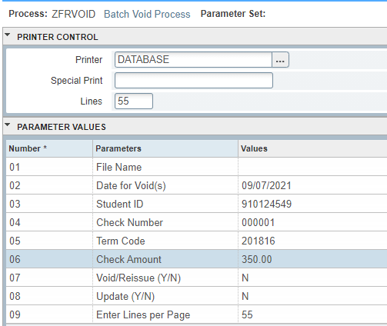

Always run in Audit mode first. Review your .log and .lis file to verify the data is correct before running in Update mode.

Below is sample output information of your .log and .lis file.
Example of ZFRVOID.log Single Void Transaction

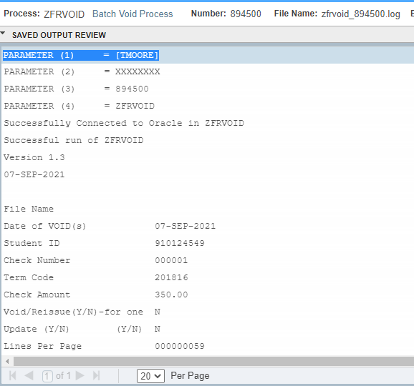

Example of ZFRVOID.lis file. Single Void Transaction. You can see that this was run in Audit mode by the “AUDIT” in the upper left corner of the .lis file.
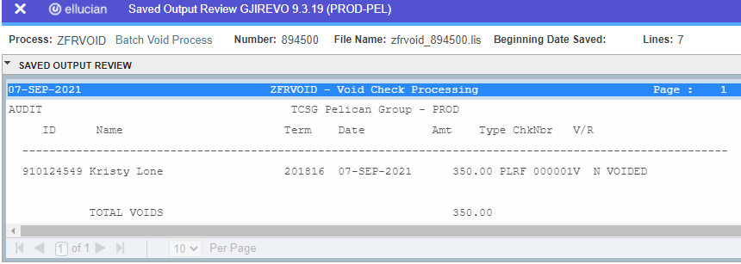
If data is correct, run in Update mode with the same parameters except for Parameter 08 (Update) it will need to be entered as Y.

Review your .lis and .log file. If all is good then verify it is correct in TSAAREV.
When voiding checks, a reversing entry will be placed on the students account and the check number will be the original check number followed by V.
This is an example of a voided transaction in TSAAREV

- Void and Reissue one student’s check

Follow the parameters below:
02 Date for Void(s) - enter the date for the voided check
03 Student ID – enter the student’s id that needs the voided check
04 Check Number – enter the check number of the check void needed.
05 Term Code – Enter the term code when voiding one check
06 Check Amount – enter the check amount when voiding one check/transaction.
07 Void/Reissue(Y/N) – Enter Y to void and reissue one transaction.
08 Update(Y/N) – Enter N for audit mode or Y to update. (Always run in Audit mode first)
09 Enter Lines per Page – defaults to 55
(None of the other parameters are to be entered.)

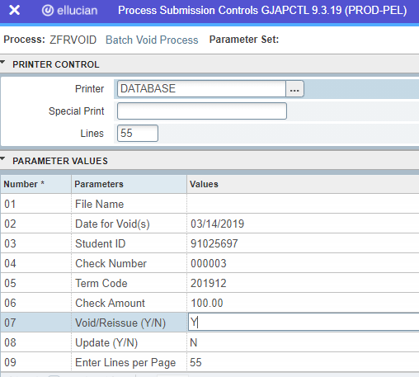

Always run in Audit mode first. Review your .log and .lis file to verify the data is correct before running in Update mode.

Below is sample output information of your .log and .lis file.
Example of ZFRVOID.log – Single Void and Reissue Transaction
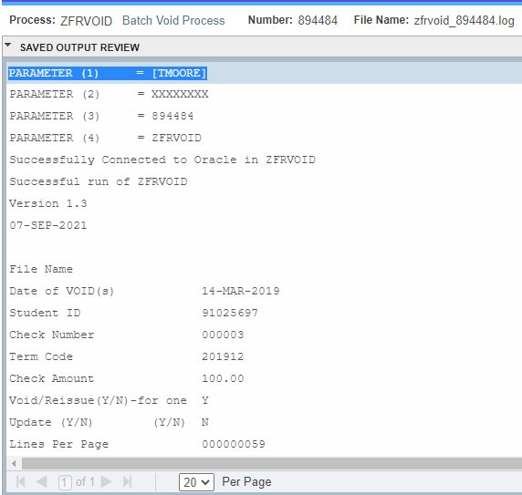

Example of ZFRVOID.lis file. Single Void and Reissue Transaction You will see an error message. The check did not void and reissue. You will need to review your data and find what is incorrect.
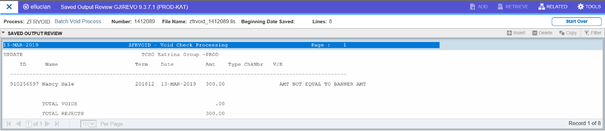

If data is correct, run in Update mode with the same parameters except for Parameter 08 (Update) it will need to be Y.

Review your .log and .lis files if all is good then verify it is correct in TSAAREV.
When voiding and reissuing checks, a reversing entry will be placed on the students account and the check number will be the original check number followed by V. Then another entry will be placed on the students account with a blank document number.
This is an example of a voided and reissued transaction in TSAAREV
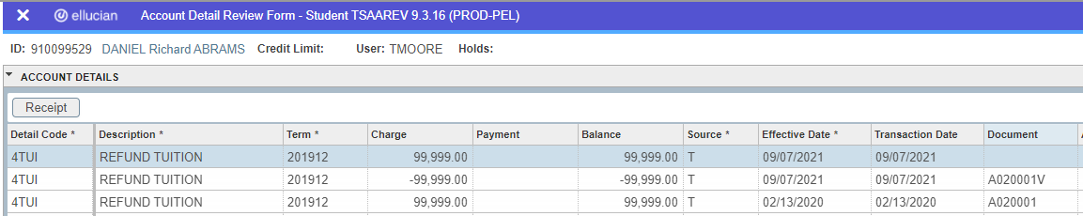

- Void multiple student’s checks or Void and reissue multiple student’s checks.
To Void Multiple Student’s Checks or Voiding and Reissuing Student’s checks, the following .csv file format must be used. The file must have the Header record. The Student ID, Name, Check/Transaction Number, Term Code, Void Amount, Void/Reissue flag must be present. Each field must be separated by commas. Only the Name is optional. If the name isn’t in the field, there must be a place setter for the field.
In this example you will find either an N or a Y (except the header record) at the end of each record, this indicates if you want to void or void and re-issue the check. N=Void the check or Y=Void and Reissue the check.
Example of the .csv file
StudID,StudName,CheckNbr,Term,CheckAmt,V/R
910101495,Joe Doe,611937,201412,125.14,N
910111847,Sally Fields,611899,201412,1021,Y
910107675,Wayne Davis,611901,201412,625.70,N
880113493,,000010,201412,568.35,Y
You can create this file in WordPad and save it as a .csv file.

The .csv file must be loaded in the /u01/app/banner/dataload/general directory. The file should be directly uploaded from the user’s computer to the banner box using the Option>>UploadFile (GUAUPLP) feature within ZFRVOID process.
Once your file has been uploaded you can use your .csv file in ZFRVOID.
Enter the following parameters to void or void and reissue checks/transactions.
01 File Name – Enter the name of the .csv file
02 Date for Void(s) – Enter the Void Check Date
08 Update(Y/N) – Enter N for Audit Mode or enter Y for Update Mode
09 Enter Lines Per Page – Defaults to 55
None of the other parameters are to be entered. The program will find all of that information in the .csv file.
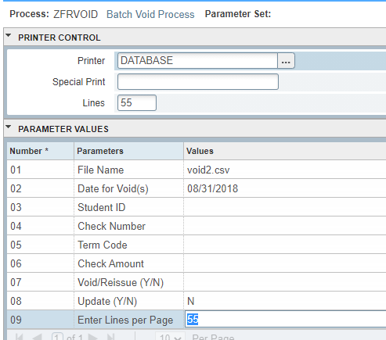
Always run in Audit mode first. Review your .log and .lis file to verify the data is correct before running in Update mode.

Review your .lis and .log file. Below is sample output information of your .log and .lis file.

Example of ZFRVOID.log – Void or Void and Reissue Check/Transactions for multiple students

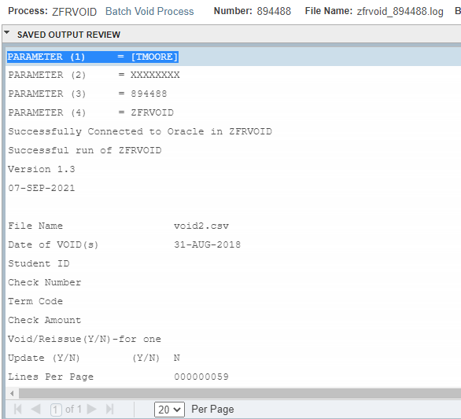
Example of ZFRVOID.lis – Void or Void and Reissue Check/Transactions for multiple students
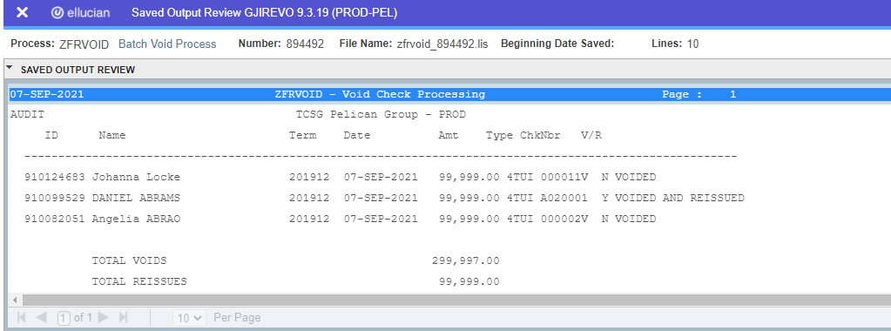
If data is correct, run in Update mode with the same parameters except for Parameter 08 (Update) it will need to be Y.

Review your .log and .lis files if all is good then verify it is correct in TSAAREV.
When voiding checks, a reversing entry will be placed on the students account and the check number will be the original check number followed by V.
This is an example of a voided transaction in TSAAREV
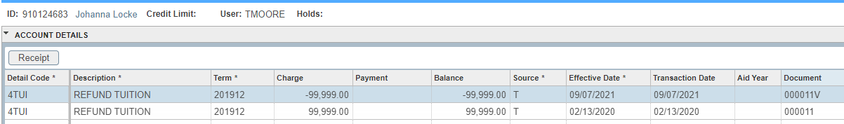
When voiding and reissuing checks, a reversing entry will be placed on the students account and the check number will be the original check number followed by V. Then another entry will be placed on the students account with a blank document number.
This is an example of a voided and reissued transaction in TSAAREV
You will then need to run ZFRCHEK to produce the new/reissued check and place the new check number in the document number field.

