TECHNICAL COLLEGE SYSTEM OF GEORGIA
ACCOUNTING PROCEDURES MANUAL

This procedure applies to technical colleges and system office.

Labor Distribution Procedure

General

The State of Georgia currently uses TeamWorks to process both Financial and Human Capital Management (HCM) accounting data. The Labor module is housed in the Financials System and allows the data housed in the HCM Module to flow to the appropriate modules of the Financials System. A quarterly calendar for payroll processing is located at http://sao.georgia.gov under TeamWorks/Calendars/Human Capital Management (HCM) Systems.

STEP 1:

Payroll confirms four business days prior to payday. There are separate payrolls for salaried employees and hourly employees. These separate payrolls are referred to as paygroups. Typical paygroups are MS1 for salaried employees and MH1 for hourly employees, though your agency may have more, particularly for hourly employees based on individual needs. The State Accounting Office (SAO) establishes the Payroll Frequency by business unit. Once payroll is “CONFIRMED”, payroll will process that night during overnight processing.

STEP 2:

After payroll has confirmed, the following reports are available in TeamWorks Report Manager:

PY8XX0018H (Payroll Summary Report) is generated to indicate a payroll was processed in HCM.

Report LDXX10001 (Labor Distribution Control Totals) is generated with the totals of the payroll that was transmitted to TeamWorks Financials. The purpose of the two reports is to compare totals sent from payroll to totals received by Labor Distribution. The amounts from both reports should agree. If these reports do not balance refer to Report LD8XX0006 (Checks Without Earnings).

STEP 2 (Continued)

PY8XX0018H (Payroll Summary Report)

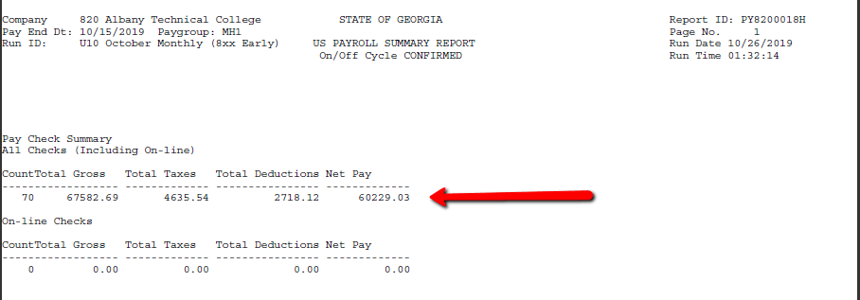

Report LD8XX0001 (Labor Distribution Control Totals)

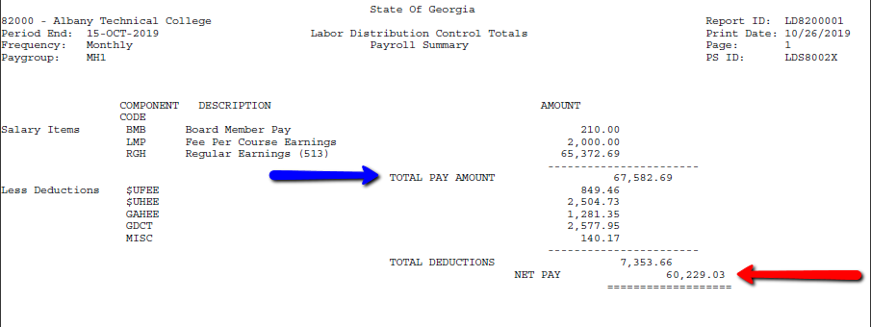

STEP 2 (Continued)

Review Report LD8XX0006 (Checks Without Earnings). This report identifies refunds/adjustments paid in payroll but not processed in Labor Distribution. Corrections to withholdings which resulted in a payment to the employee when the employee had no earnings must be entered by manual journal vouchers.

Review Report LD8XX0002 (Labor Distribution Messages). This report identifies chartfield edit errors that were not corrected in Payroll and were sent to Labor Distribution. These errors must be corrected before Labor can be released to the general ledger for posting.
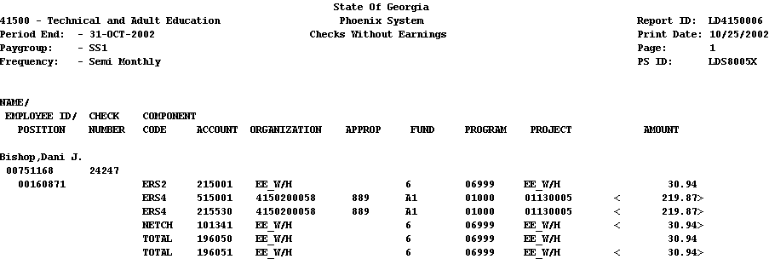

In this example, the message “Effective date not valid for Project” means the project had an end date prior to the date of this payroll. In this situation contact the staff of the TCSG Budget Office to extend the project’s end date. When a previous year’s chartfield was entered due to an error, the error could be easily corrected by manually changing the chartfield to a current chartfield in TeamWorks Financials Labor Distribution prior to Labor Release.

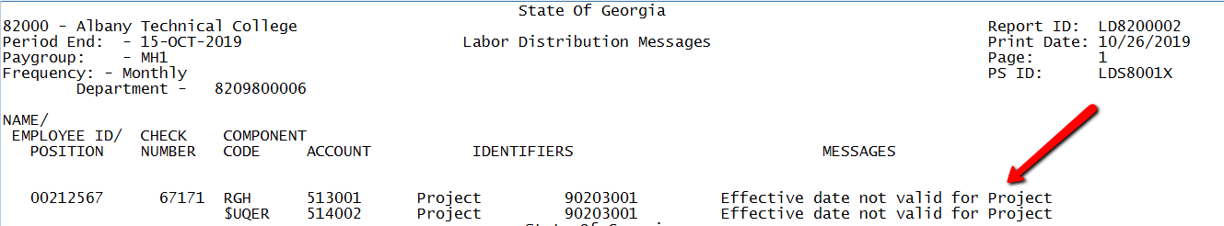

STEP 3

After payroll confirms, the Payroll Technician reviews all employees’ labor codes to ensure that the employees are being charged to the correct project, fund, fund source, class, subprogram, and department. Only errors made in the chartfield(s) can be corrected in TeamWorks Financials Labor Distribution. For example, the project or program can be changed. Even though an account field is not grayed out, this field should never be changed. To access Labor Distribution in TeamWorks Financials, click on the Labor Distribution tile and then Labor Distribution.
STEP 3 (Continued)

The Director of Accounting or designee should release payroll the day after confirm. Navigate to the Release Labor link through the Labor Distribution tile in TeamWorks Financials.
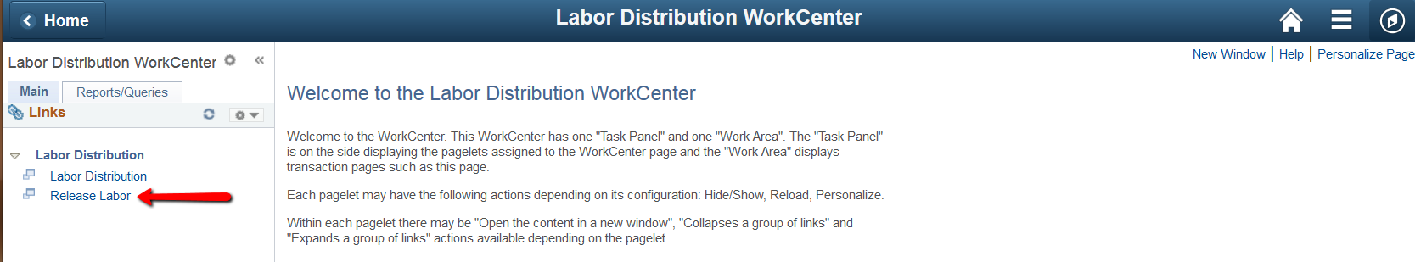

If a Run Control ID does not already exist, one should be set up for each paygroup for release:

MS1

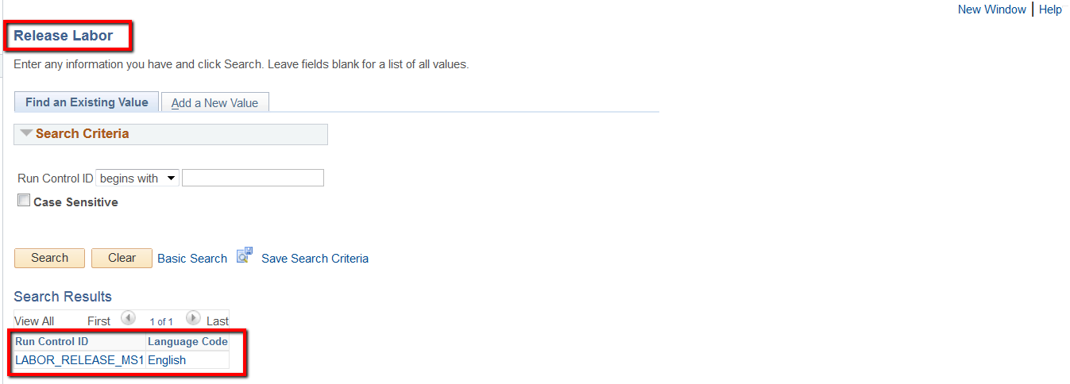
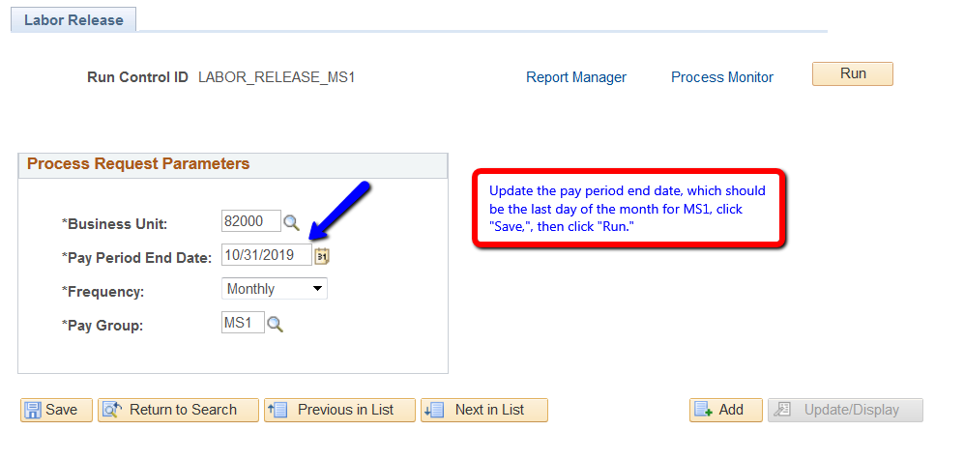

STEP 3 (Continued)

MH1

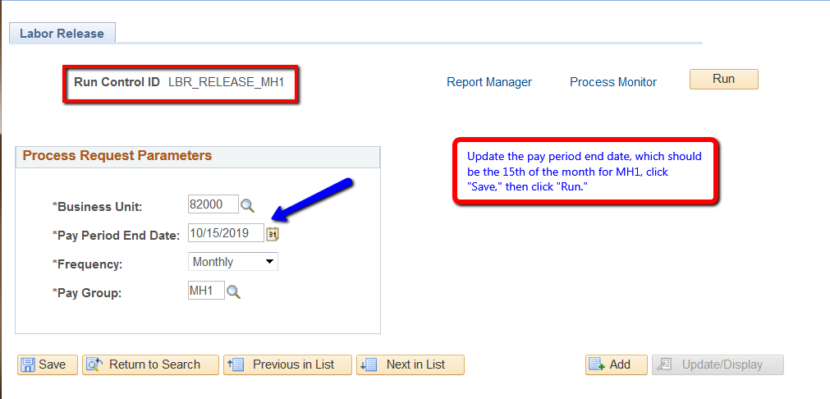

Payroll will not be sent to the General Ledger nor the fringes posted to the Accounts Payable module until the payroll is “Released.”

If any corrections to chartfields (project, program, organization) were made in Labor Distribution, Report LD8XX0004 (Labor Distribution Corrections) will be generated and available in TeamWorks Financials Report Manager. Once labor is released, the Labor Distribution panel will not be available for corrections.

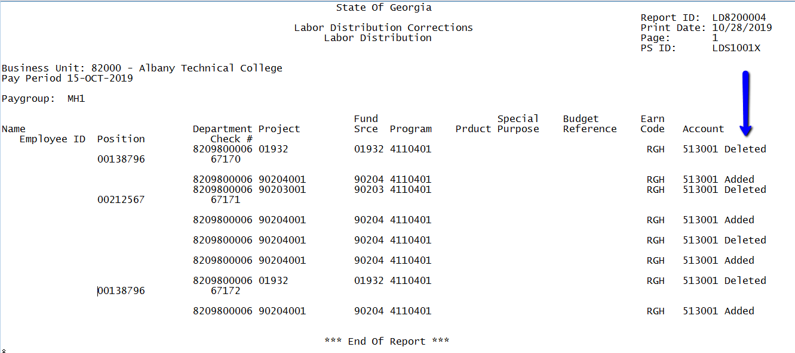

STEP 3 (Continued)

Once payroll is released, Report LD8XX0005 (Labor Distribution Messages) will be generated only if there are chartfield errors. Once the errors are corrected, payroll for the affected paygroup will have to be re-released.

STEP 4
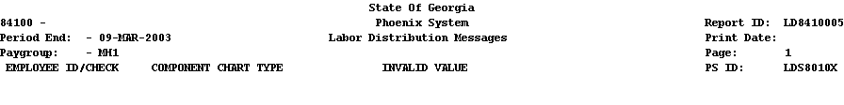

00700232 11420 RGH PROJECT_ID 31113003
00813603 11423 RGH PROJECT_ID 31113003

Once labor is released with no errors, the journal goes through overnight processing for budget checking. If the journal passes budget checking, then the journal is transmitted to the General Ledger and Accounts Payable module. The journal will then be posted in TeamWorks Financials, and financial reports will reflect the amounts.

The day after labor is released, the Director of Accounting or designee must verify that the labor journal has posted successfully to the General Ledger. There are two ways to do this: 1) Run the GL020 query to see if labor has posted to the General Ledger. If the query is blank, then the Director of Accounting reviews the GL8XX0416 Error Report to determine what the errors are and reviews those errors with the Payroll Technician to determine what action needs to be taken to correct the error(s); or 2) Navigate to the General Ledger tile, click on “Create/Update Journal Entries, “Find an Existing Value,” and clear all fields with the exception of the Business Unit and the Source, which should equal “LD,” click “Search” and scroll all the way to the bottom for the most recent journal to confirm that the budget check is “Valid” and the journal status is “Posted.” If the journal did not post, “Error” will show in either the Journal Status or Budget Status fields.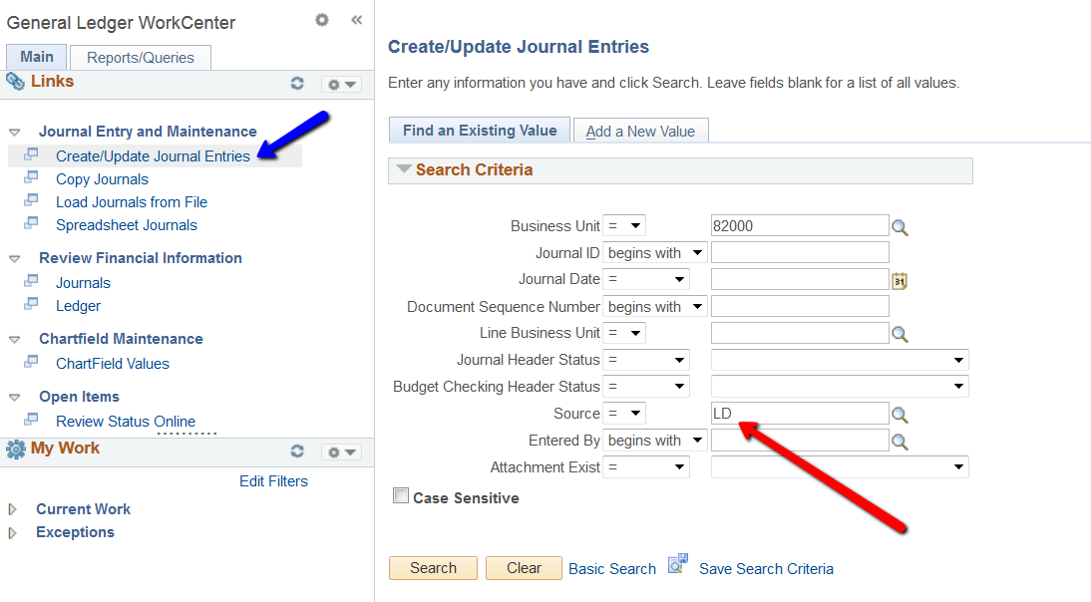

STEP 4 (Continued)

If the error is budget related, then the Vice President of Administration or designee may need to load a budget for those line items before labor will post to the General Ledger. If there are errors that are not budget related, then the Director of Accounting corrects the LD journal voucher and the journal will post during overnight processing. (Note: Labor journals are available to view after the journals are posted.)

To determine the errors on the labor journal, open the journal voucher for the current period. Once the labor journal is open, click on the “Lines” tab at the top. If there are errors that need to be corrected, there will be an “E” in either the Journal Status or Budget Status fields. If there is a “P” in the Journal Status field, the journal was successfully posted to the General Ledger. Consequently, there will be a “V” in the Budget Status field indicating a valid budget check.

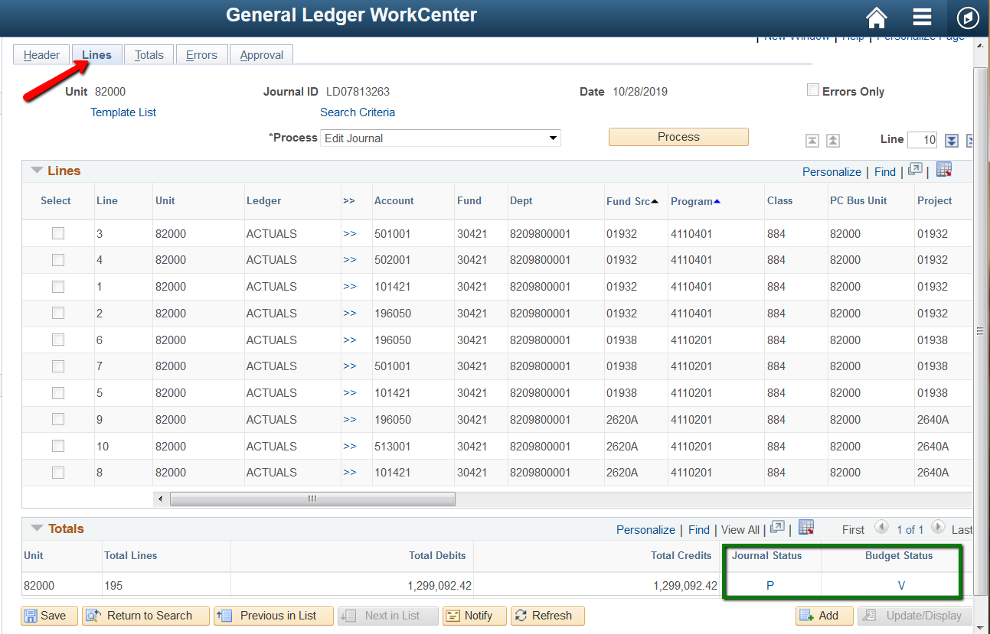

Identifying and Correcting Labor Journal Errors

Go to the Journal Entry Lines Panel.
- Click on the “E” in the Budget Status field to see error details. Or, click on the “Errors Only” box to see affected lines.

STEP 4 (Continued)

- Determine the cause of errors.
Typically, there are two types of errors: Budget Error and Chartfield Error.
Budget Error results from budget line being insufficient to cover expenditures and can be corrected by increasing the amount of the budget line.
Chartfield Error usually results when an invalid chartfield combination was used. (i.e., previous year’s project number)
- Click anywhere on the line that has errors.
- Correct the errors and click on save.
- Click on the Process dropdown to choose “Edit Journal” and then click “Process.” Once all budget errors are corrected, a “V” will display at the bottom in the Budget Status field.

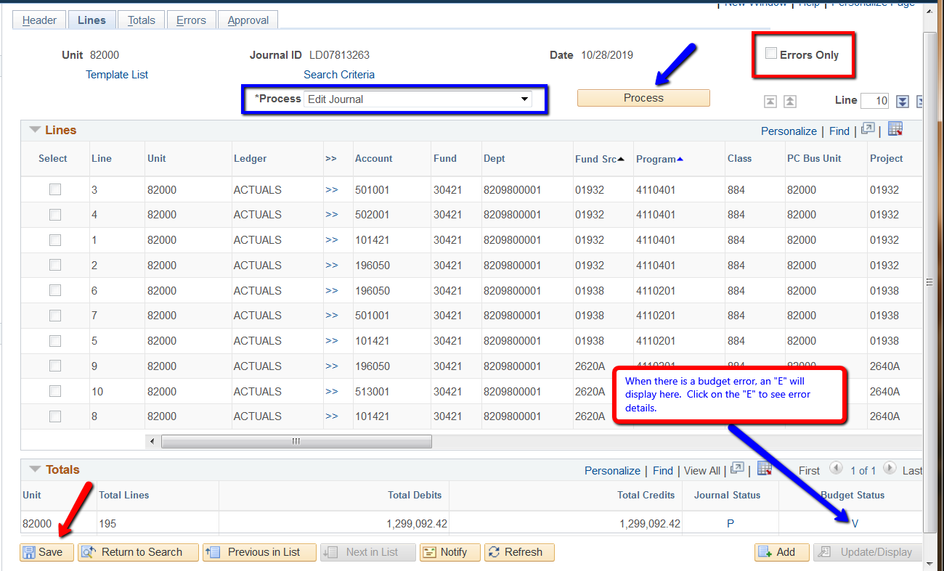

STEP 5

Report LD8XX10210 (Labor Expense Detail by Department) automatically runs when Labor is released. This report shows the distribution of projects and programs from the Account Code Table. The Payroll Technician will then request reports LD8XX021P (Labor Expense Detail by Project) and LD8XX021F (Labor Expense Detail by Fund Source) for all paygroups. These reports should be retained one year for accounting purposes.

