STUDENT DIRECT DEPOSITS (ACH)
Set up and Processing of Checks

The form GXRBANK should be filled out for each bank account from which the college will be sending student direct deposits (typically PELL and Loan accounts). The first account is normally called Bank 01. The name of the account can be a simple, descriptive name such as HOPE. The bank ID should be the bank name in all caps (set the bank ID in SPAIDEN first). The description should be the full bank name. The Bank Account number should be the school’s bank account number for the account referenced in the name at the top of the screen. (See example below).
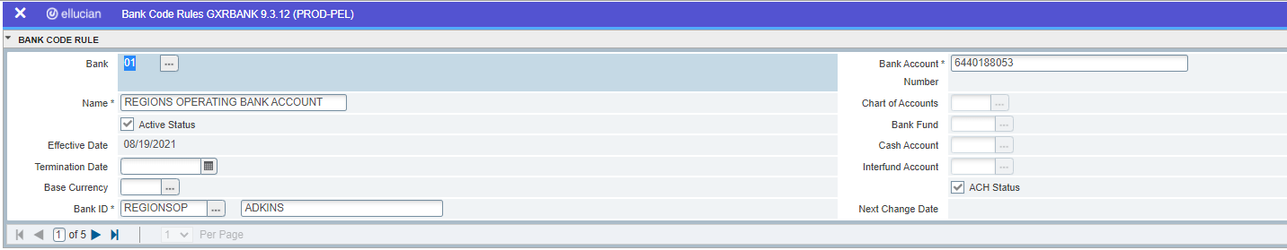
To enter specific ACH information, enter Tools>>ACH Rules. The second screen of GXRBANK must be filled out for each bank account.
The Destination ID is the bank’s routing number. You will need to check with your bank to see if a space needs to be in front of the routing number in the ACH File Header record. If so, you will need to put a space before the routing number in the Destination ID field.
The Destination Name is the name of the Clearing House the bank uses. Make sure this field is entered in all caps. You can get this information from your bank.
The Origin ID value will come from the bank. Each bank requires a different value in this field.
The Origin Name is the Long name of the School. Make sure this field is entered in all caps.
The Short Name is usually the description found on the Bank Statement. Some schools may use values like HOPE or PELL, while other schools use just a short abbreviated school name. Make sure this field is entered in all caps.
The originating Bank Routing Number is the routing number of the school’s Bank account. This field is normally left justified.
Click on IRS Employer (EIN) and enter the College’s FEI Number in the Organization ID Number field.
After all information has been entered, hit F10 to save. If you find that any of these fields are incorrect, you must re-enter both screens of information again, using F6 (Record Insert). You may not know if these values are incorrect until you get ready to generate a pre-note file using ZFRNOTE (the file may not generate) or until you actually send the pre-note file to your bank for review. (See example below).
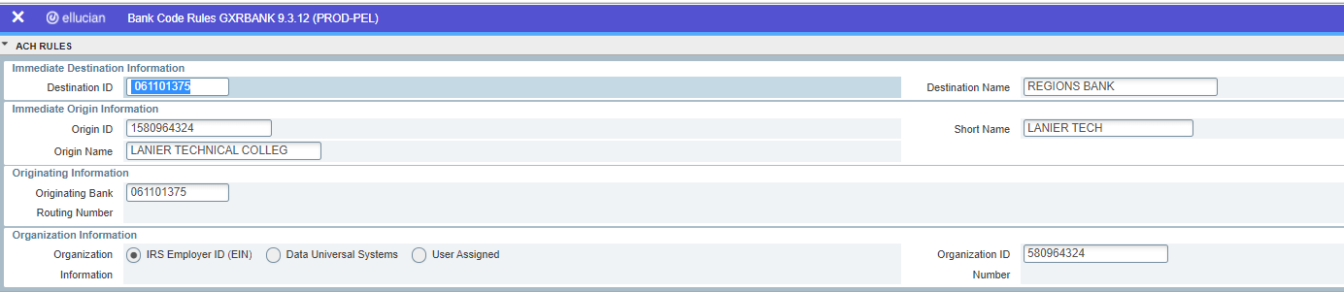
To do a second account (i.e. Pell) hit F10 to save the first account and enter the information about the second account in the same manner as above, using Bank number 02 for the second account. The school’s bank accounts have now been established.
Security note: Maintenance Security for GXRBANK should only be given to key staff. Have technical support staff verify the security for this table. Read-only security should not be available for this form.

Have the students fill out a form to sign up for direct deposit. Also have the student’s submit a voided check with the form. You must set up the routing number for each bank you will be depositing into from the information on the student’s direct deposit forms and voided checks. This is done once per bank on the GXVDIRD screen. Enter the routing number for the student’s bank and the Bank name. Save. This will only need to be done once no matter how many students use that bank. You may want to consult the current routing IDs that are available for Peoplesoft Payroll.
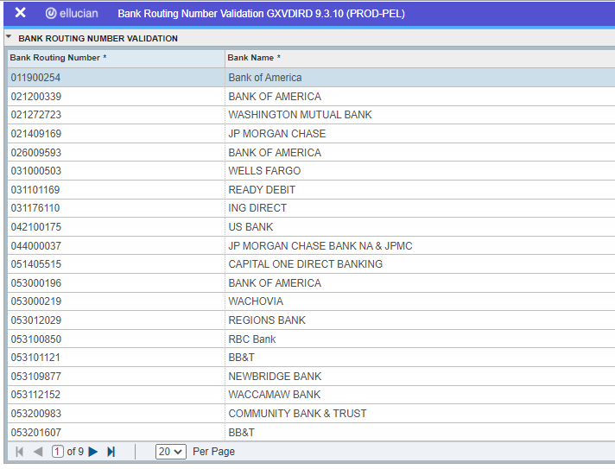
Use screen GXVDIRD to set up the routing number for the student’s bank if it has not already been set up.
Go to the GXADIRD screen and enter the student’s ID number. Enter the routing number of the student’s bank account (this must be entered into GXVDIRD first). Enter the Account number of the student’s account and check whether it is a checking or a savings account. The initial Direct Deposit Status should be Prenote. Save.
Security note: Maintenance Security for GXADIRD should only be given to key staff or certain cashiers. Have technical support staff verify the security for this table. Read-only security should not be available for this form.
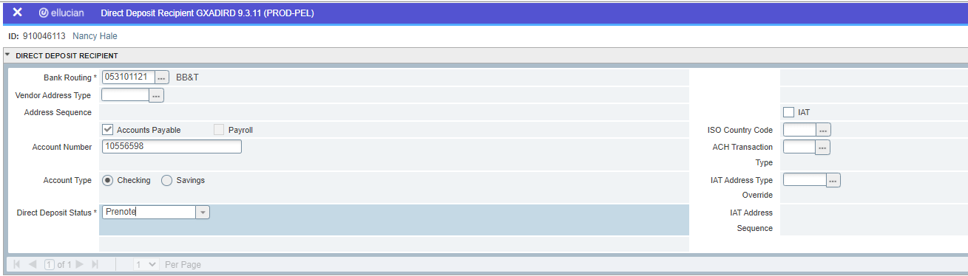
A Prenote file should be sent to the banks each semester to make sure the students have not closed accounts and that the account numbers and routing numbers are correct. This should be done at least two weeks before you wish to send the actual direct deposits to the banks. To create a Prenote file for the bank, run ZFRNOTE. This will create a listing of all students with a direct deposit status of Pre-note or you may include all of your students to make sure none of them have closed accounts since the semester.
Parameter 01 – Enter the date of the direct deposit prenote.
Parameter 02 - Enter the current term.
Parameter 03 - Enter Selection Identifier if using a Popsel
Parameter 04 - Enter Application Code if using a Popsel
Parameter 05 - Enter the Creator ID if using a Popsel
Parameter 06 - Enter User if using a Popsel.
Parameter 07 - Enter Y to produce an actual file. Enter N to run in audit mode.
Parameter 08 – Enter any college bank code (01, 02, etc.)
Parameter 09 – Enter Y to change the student status to “active” after creating the file
Parameter 10 - Enter Y to include all active direct deposit students in the prenote file
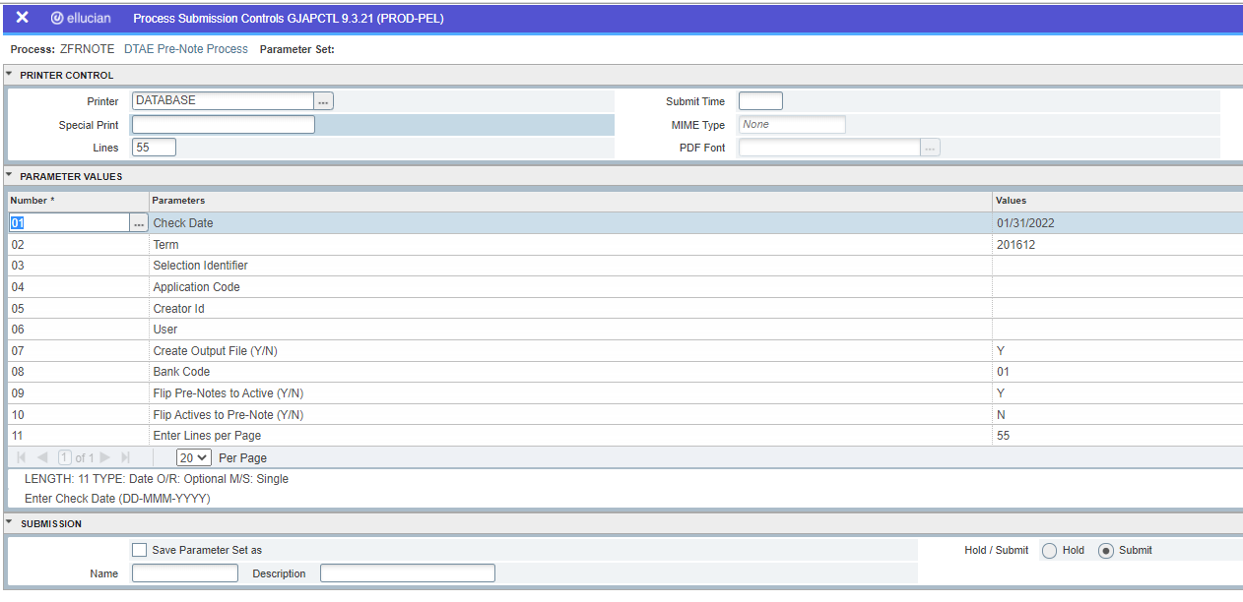
Once the file is produced, go to Secure FX and find the Pxxxxxx file you just created in the /u01/app/banner/dataload/general/ directory. Save the file as a .txt file. Send this file to your bank in the manner they prefer using the bank’s secure web site. This is a “$0.00” file and it will not send any funds to the student accounts, it just verifies the accuracy of the routing and account numbers for a future direct deposit.

Security note: Maintenance Security for ZFRNOTE should only be given to key staff. Have technical support staff verify the security for this object. Additionally, even if this data doesn’t contain dollars, the pach file should be removed from the Banner system once key staff has processed this information. Additional care should be taken to ensure this data is not stored on laptops once transmitted to your bank via an SSL and 128-bit encryption method.

To send your actual direct deposit file run the process ZFRCHEK.
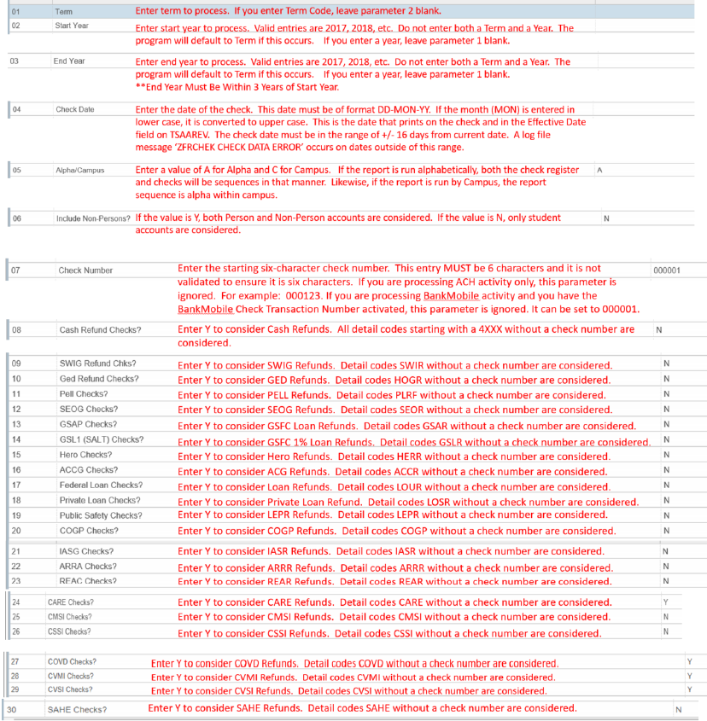
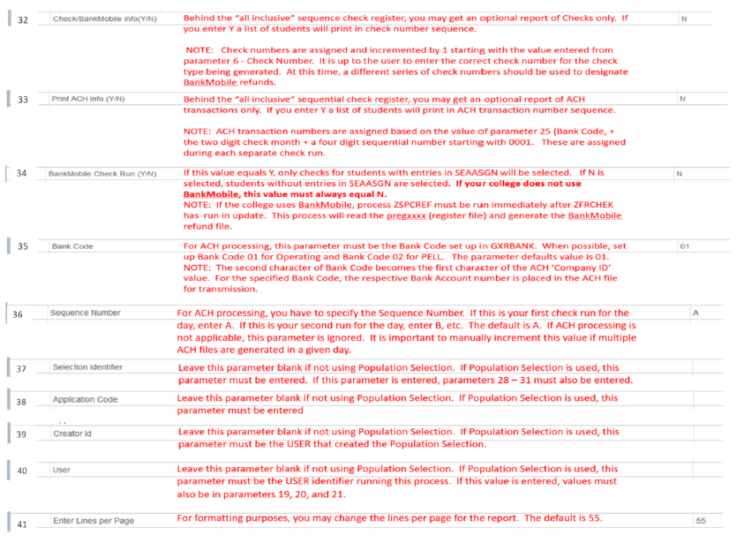
Once the checks and the direct deposit file are produced, pull down the /u01/app/banner/dataload/general/pach* file as a .txt file. Send this file to your bank on their secure web site. This will send the funds to the student accounts for all students with a status of “active” in GXADIRD.
Security note: For security purposes, the pach file should be removed from the Banner system once key staff has processed this information. Additional care should be taken to ensure this data is not stored on laptops once transmitted to your bank via an SSL and 128-bit encryption method.
To make a student’s direct deposit inactive, go to GXADIRD. Enter the student’s ID number and click on the down arrow next to the field “Direct Deposit Status”. Change the status to “inactive” and save.
To change the student’s bank account number, go to GXADIRD. Enter the student’s ID number and click on the down arrow next to the field “Bank Routing”. Find the appropriate routing number. If it doesn’t exist, go to GXVDIRD and set it up. On GXADIRD change the bank routing number for the student and the account number for the student. Also check whether it is a checking or savings account. Change the direct deposit status to pre-note if necessary (recommended). Save.
You may need to use the Debit Prenote file should be sent to the banks each semester to make sure the students have not closed accounts and that the account numbers and routing numbers are correct. This should be done at least two weeks before you wish to send the actual direct deposits to the banks. To create a Prenote file for the bank, run ZFRNOTE. This will create a listing of all students with a direct deposit status

